**DATE: 30-03-22**

**WEBLEM 9**

**Introduction to Genomics & its various browser (UCSC, ENSEMBL, GDV)**

**Genomics** is the **study of genomes**. Genomic studies are characterized by **simultaneous analysis of a large number** of genes using **automated data gathering tools**. The topics of **genomics range** from genome **mapping sequencing**, and **functional genomic analysis** to comparative **genomic analysis**. The **advent of genomics** and the ensuing explosion of **sequence information** are the main driving force behind the **rapid development** of bioinformatics today.

Genomic study can be **tentatively divided** into **structural genomics** and **functional genomics**. Structural genomics refers to the **initial phase of genome analysis**, which includes construction of **genetic and physical maps** of a genome, identification of genes, **annotation of gene features**, and **comparison of genome structures**. Functional genomics refers to the analysis of **global gene expression** and gene functions in a genome.

Genome browsers are resources that **integrate data at the genomic level**, thereby allowing visualization of related **genomic information** in one space. These data can **include genes**, **noncoding elements** that regulate **gene expression**, **genetic variation** and the results of **comparative genomics analyses**, among other forms of annotation. Commonly used genome **browsers include Ensembl**, the **UCSC Genome Browser** and **GDV**.

1. **UCSC Genome Browser**

The **University of California Santa Cruz** (UCSC) **Genome Browser** (genome.ucsc.edu) is a popular **Web-based tool** for quickly displaying a requested **portion of a genome** at any scale, accompanied by a series of **aligned annotation “tracks”.** The annotations generated by the **UCSC Genome Bioinformatics Group** and external collaborators display **gene predictions**, **mRNA** and **expressed sequence tag alignments**, **simple nucleotide polymorphisms**, **expression** and **regulatory data**, **phenotype** and **variation data**, and **pairwise** and **multiple-species comparative** genomics data. All **information relevant** to a region is presented **in one window**, facilitating **biological analysis** and **interpretation**. The database tables **underlying the Genome Browser tracks** can be **viewed**, **downloaded**, and **manipulated** using another **Web-based application**, the UCSC Table Browser. Users can upload data as **custom annotation tracks** in both browsers for research or educational use.

The **vast size** of vertebrate genome data sets **presents challenges** in **efficient data storage** and **retrieval**. In addition, the **burgeoning number** of versions of a **particular genome demands** a process that can **rapidly integrate new data** and annotations into the database while **implementing creative solutions** for maintaining and **enhancing views of the data**. Through **software algorithmic refinements** and optimizations to **both the database and hardware**, the UCSC Genome Browser viewer maintains the **same interactive** response time on the **large Homo sapiens** and **Mus musculus genomes** that its predecessor had on the **much smaller Caenorhabditis** elegans genome.

**Sequence and annotation** data for each genome assembly are **stored in a MySQL relational database**, which is **quite efficient at retrieving data** from indexed files. The **database is loaded** in large batches and is used **primarily as a read-only database**. To improve performance, each of the Genome Browser web servers has a **copy of the database on its local disk**. UCSC **generates several annotations** based on **mRNA alignments**. The **mRNA and EST sequences** are extracted from GenBank, and are **aligned** against the genome **using the BLAST-like Alignment Tool** (BLAT), a fast sequence alignment tool developed by Jim Kent. The **data is filtered based on percentage identity** and near best in genome to select only those alignments that **best match the sequence**. The **spliced EST** annotation is computed from the **filtered data by analyzing** the EST alignments for **evidence of splicing**.

1. **ENSEMBL gene browser**

**The Ensembl project** was initially launched in **1999** with the aim of **developing methodologies** for **automatic annotation** of (human) **genomic sequence** with genes and their **constituent transcripts**. Since that time, the project has broadened substantially in scope; the **Ensembl Genome Browser**, which came online in **2000**, now includes **reference genomic sequence** and **annotation** for nearly **100 chordate organisms**. Ensembl is **rapidly incorporating** new data, including **whole clades** of new species’ genomes and reference sequence for **multiple strains of existing species**, such as mouse. In addition, existing annotation is **regularly augmented** by the **inclusion of new data sets**. Ensembl’s sister site, **Ensembl Genomes**, provides access to **nonvertebrate genomes** through dedicated portals for **Bacteria, Fungi, Plants, Metazoa, and Protists.**

**Ensembl data**, **annotations**, and analyses are updated **every 2−3 months**, alongside **software updates** to both the **public-facing website** and the **underlying databases**. A dedicated site is also maintained for the **GRCh37 reference human genome assembly**, which is annotated with **new data on a limited basis**; partial data from **ongoing genome annotation** can be accessed via the preview Pre! site.

Data from Ensembl can be **accessed at multiple scales**. Data can be accessed through the browser web pages and **via BioMart**, a web-based tool that allows **customized retrieval** of data from the **Ensembl databases**. However, data can also be **accessed programmatically** via our **Perl and REST APIs.** Files containing **genome-wide data** are available for all species **represented in Ensembl** via an FTP site; data from all releases of **Ensembl** can be **retrieved** from the **FTP site**, or from our databases via the **Perl APIs, in perpetuity.**

1. **Genome Data Viewer**

**GDV** is composed of an **embedded instance of SV** that displays **sequence and track data**, along with **additional page elements** that allow a user to **search within an entire genome** assembly and efficiently **narrow in on their chromosome**, **sequence**, **region**, or **gene of interest**. GDV replaced the NCBI Map Viewer, **NCBI's previous** tool for whole-genome display. Researchers using GDV **can go directly** to the **NCBI BLAST** service from the browser and **load BLAST results** as alignment tracks that can be viewed **side by side** with **gene annotation** and other data. **Variation Viewer**, a related browser **associated with NCBI's** variation resources, is **functionally similar to GDV** and also **incorporates an instance of SV** but is **configured with features specifically intended for analyzing human variation data**. GDV and Variation Viewer can both **display the same types of NCBI** variation track data.

The GDV **can be accessed** from its own **home page** and can also be **found via links** from other **NCBI resources, including gene, assembly, GEO, and dbGaP record pages**. GDV provides users a graphical gateway to data at the NCBI, **especially RefSeq and refSNP** annotation. Below, we highlight **some of the functions** of GDV and other instances of the **NCBI SV** and provide context for **GDV's** features with respect to the **broader collection** of publicly available **genome browsers**, including the **UCSC** and **Ensembl genome browsers**, **JBrowse**, and **IGV**. **GDV** was designed specifically to **support visualization** and **analysis** of the wide range of genomes and assemblies annotated at the NCBI. **RefSeq gene annotation** data tracks are shown by default in the **graphical view** for these assemblies. **NCBI refSNP data tracks** are also shown by default for **human assemblies**. **Gene and SNP tracks** are **automatically updated** in **GDV** and **SV** embedded instances upon **new releases** of the NCBI databases, so that **users of the NCBI graphical viewers** always have immediate access to the **latest versions of RefSeq and SNP annotation.**

GDV offers users the ability to **customize the displays of individual tracks**. Users can **hide** or **configure** tracks from the **track configuration panel** or by using the icons at the right end of each track. Different **public genome browsers provide conceptually similar**, but somewhat **distinct options**, for **visualizing** **gene, graphical, and alignment data**. In this section, we highlight **track data visualizations** in the GDV browser and other instances of the **SV graphical** view component that support various **analysis scenarios**.

**REFERENCES:**

1. Xiong, J. (2008). Genome Mapping, Assembly, and Comparison. Essential bioinformatics. Cambridge: Cambridge University Press. 243.
2. Baxevanis, Andreas D.; Petsko, Gregory A.; Stein, Lincoln D.; Stormo, Gary D. (2002). Current Protocols in Bioinformatics || The UCSC Genome Browser. , (), –. doi:10.1002/0471250953.bi0104s28
3. Karolchik, D. (2003). The UCSC Genome Browser Database. , 31(1), 51–54. doi:10.1093/nar/gkg129
4. Birney, E. (2004). An Overview of Ensembl. Genome Research, 14(5), 925–928. doi:10.1101/gr.1860604
5. Kollmar, Martin (2018). [Methods in Molecular Biology] Eukaryotic Genomic Databases Volume 1757 || The Ensembl Genome Browser: Strategies for Accessing Eukaryotic Genome Data. , 10.1007/978-1-4939-7737-6(Chapter 6), 115–139. doi:10.1007/978-1-4939-7737-6_6
6. Rangwala, S. H., Kuznetsov, A., Ananiev, V., Asztalos, A., Borodin, E., Evgeniev, V., Joukov, V., Lotov, V., Pannu, R., Rudnev, D., Shkeda, A., Weitz, E. M., & Schneider, V. A. (2020). Accessing NCBI data using the NCBI Sequence Viewer and Genome Data Viewer (GDV). Genome Research, gr.266932.120. <https://doi.org/10.1101/gr.266932.120>

**DATE: 30-03-22**

**WEBLEM 9a**

**UCSC Genome Browser**

**(URL:** [**https://genome.ucsc.edu/**](https://genome.ucsc.edu/)**)**

**AIM:**

To explore UCSC genome browser in order to understand the gene, its related studies & protein level information.

**INTRODUCTION:**

The **University of California Santa Cruz** (UCSC) **Genome Browser** (genome.ucsc.edu) is a popular **Web-based tool** for quickly displaying a requested **portion of a genome** at any scale, accompanied by a series of **aligned annotation “tracks”.** The annotations generated by the **UCSC Genome Bioinformatics Group** and external collaborators display **gene predictions**, **mRNA** and **expressed sequence tag alignments**, **simple nucleotide polymorphisms**, **expression** and **regulatory data**, **phenotype** and **variation data**, and **pairwise** and **multiple-species comparative** genomics data. All **information relevant** to a region is presented **in one window**, facilitating **biological analysis** and **interpretation**. The database tables **underlying the Genome Browser tracks** can be **viewed**, **downloaded**, and **manipulated** using another **Web-based application**, the UCSC Table Browser. Users can upload data as **custom annotation tracks** in both browsers for research or educational use.

**METHODOLOGY:**

1. Open homepage for UCSC browser (URL: <https://genome.ucsc.edu/>)
2. Select genome browser.
3. Select human assembly (GRCh3/hg38)
4. Navigate results through gene name, SNP id, Ref_Seq, OMIM id, coordinates and cytological band.
5. Use tools for zooming tracks in and out, configuration by right click, drag and select and various option available at bottom of the page.
6. Observer and interpret the results.

**OBSERVATION:**

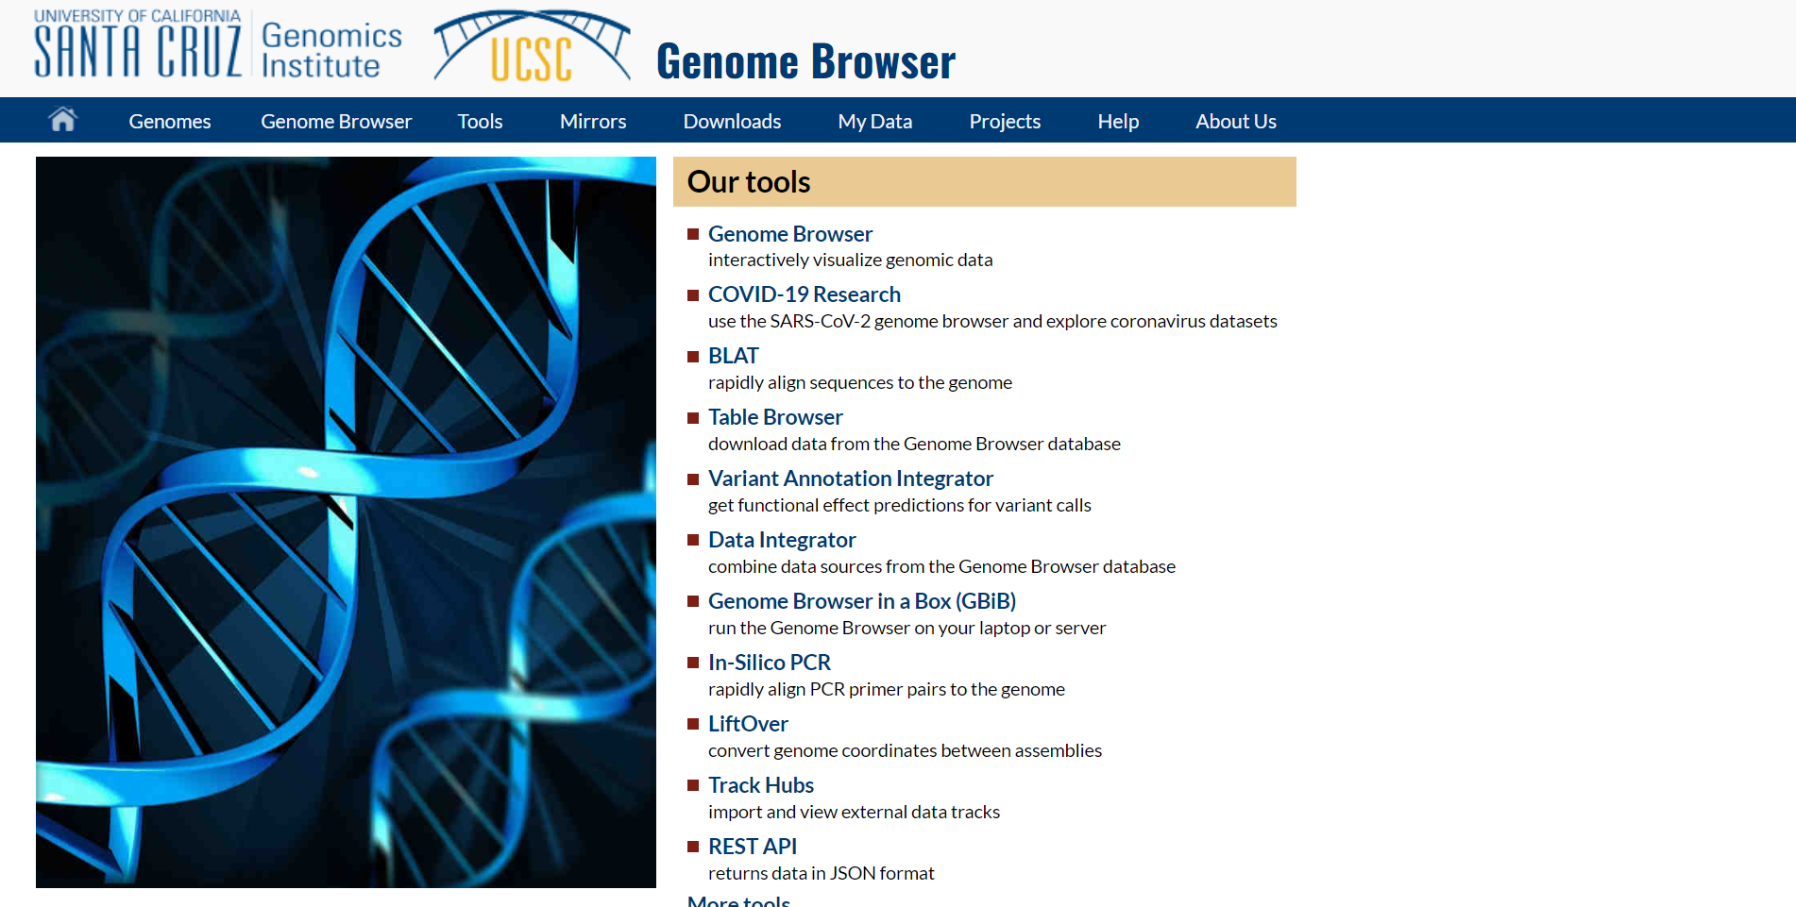**Fig1. Homepage of UCSC browser**

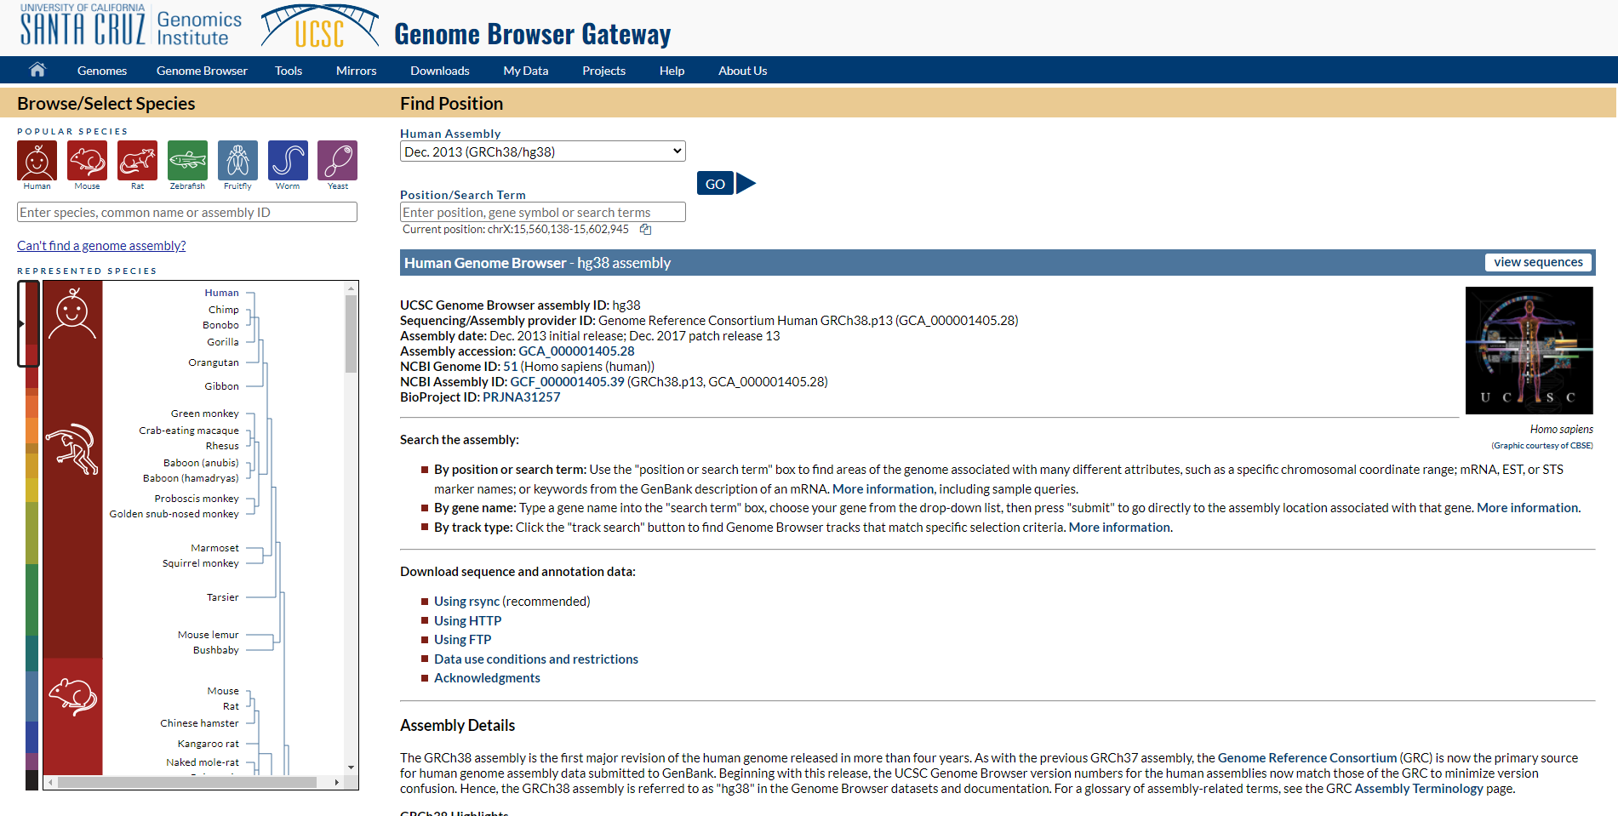**Fig2. Genome browser gateway**

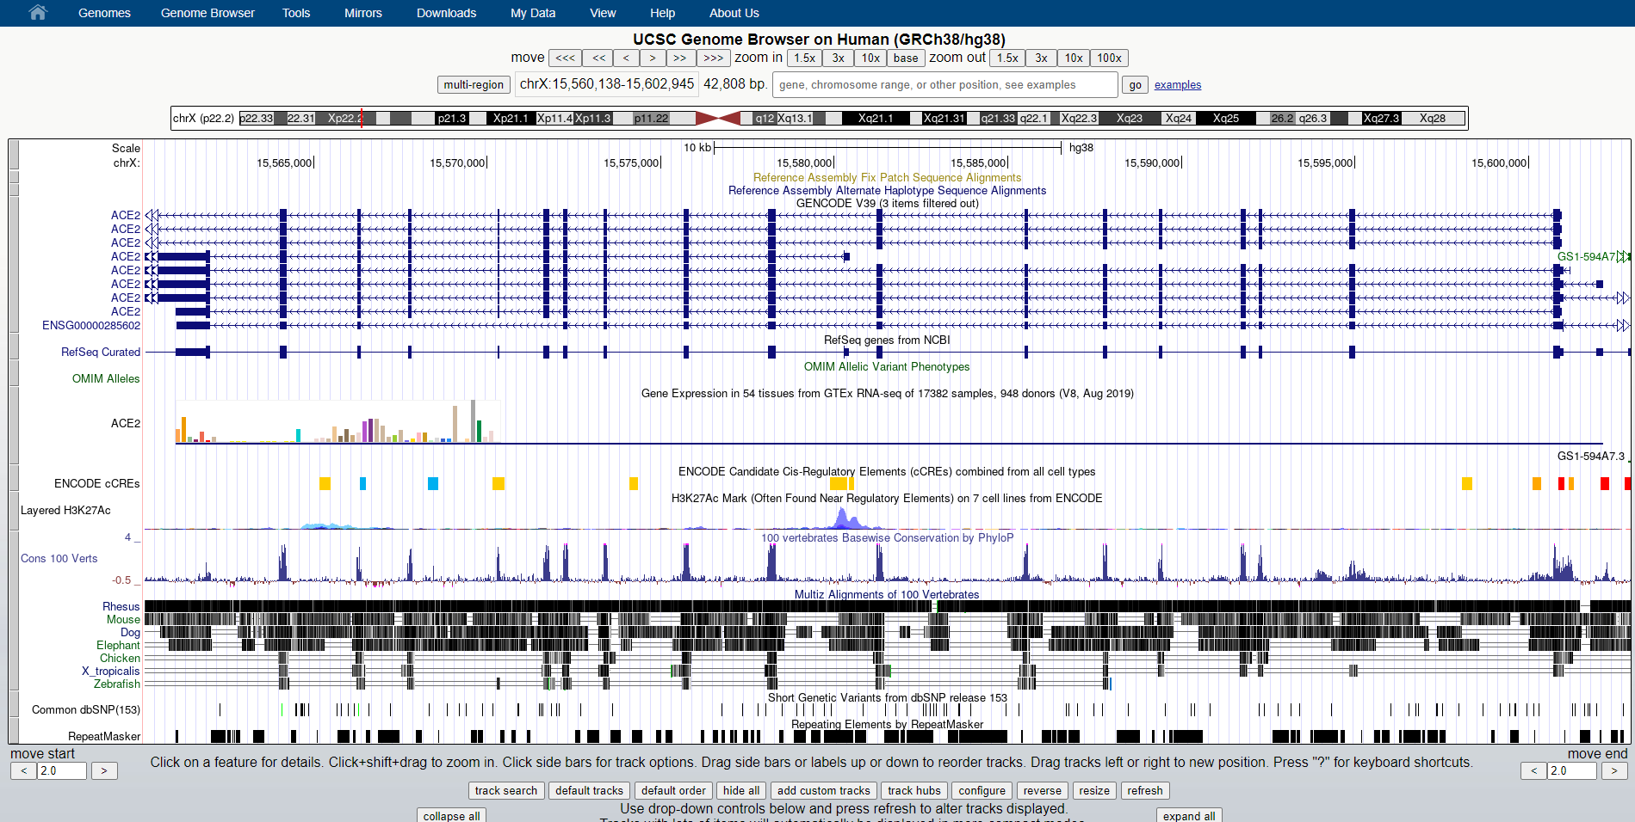**Fig3. UCSC genome browser on human (GRCh38/hg38)**

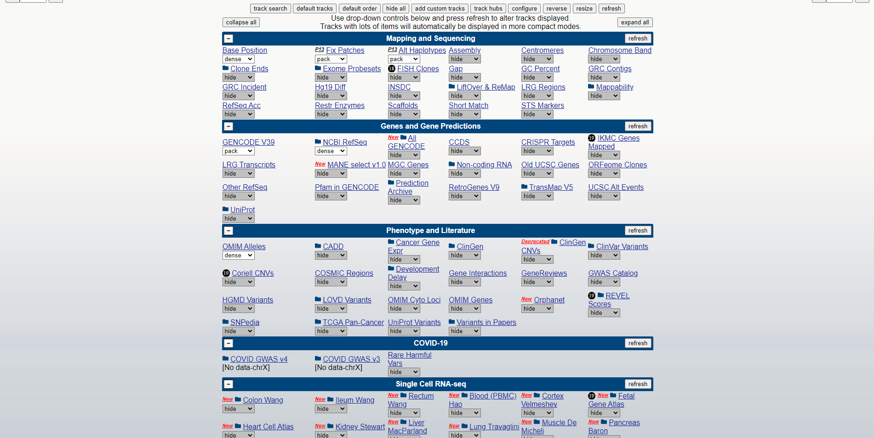**Fig4. Options for customization**

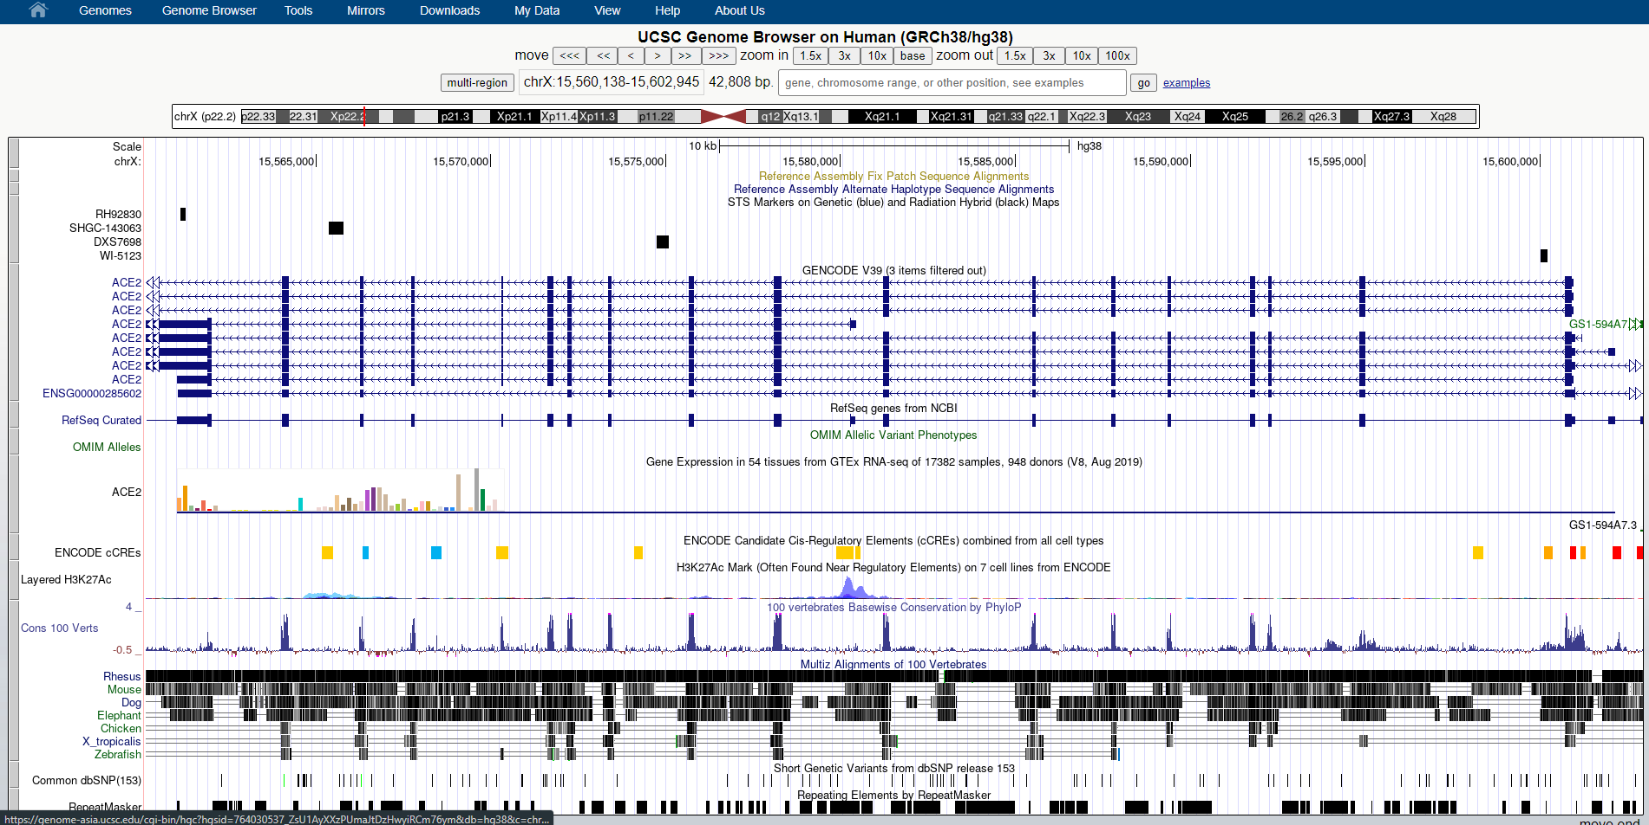**Fig5. Results after customization**

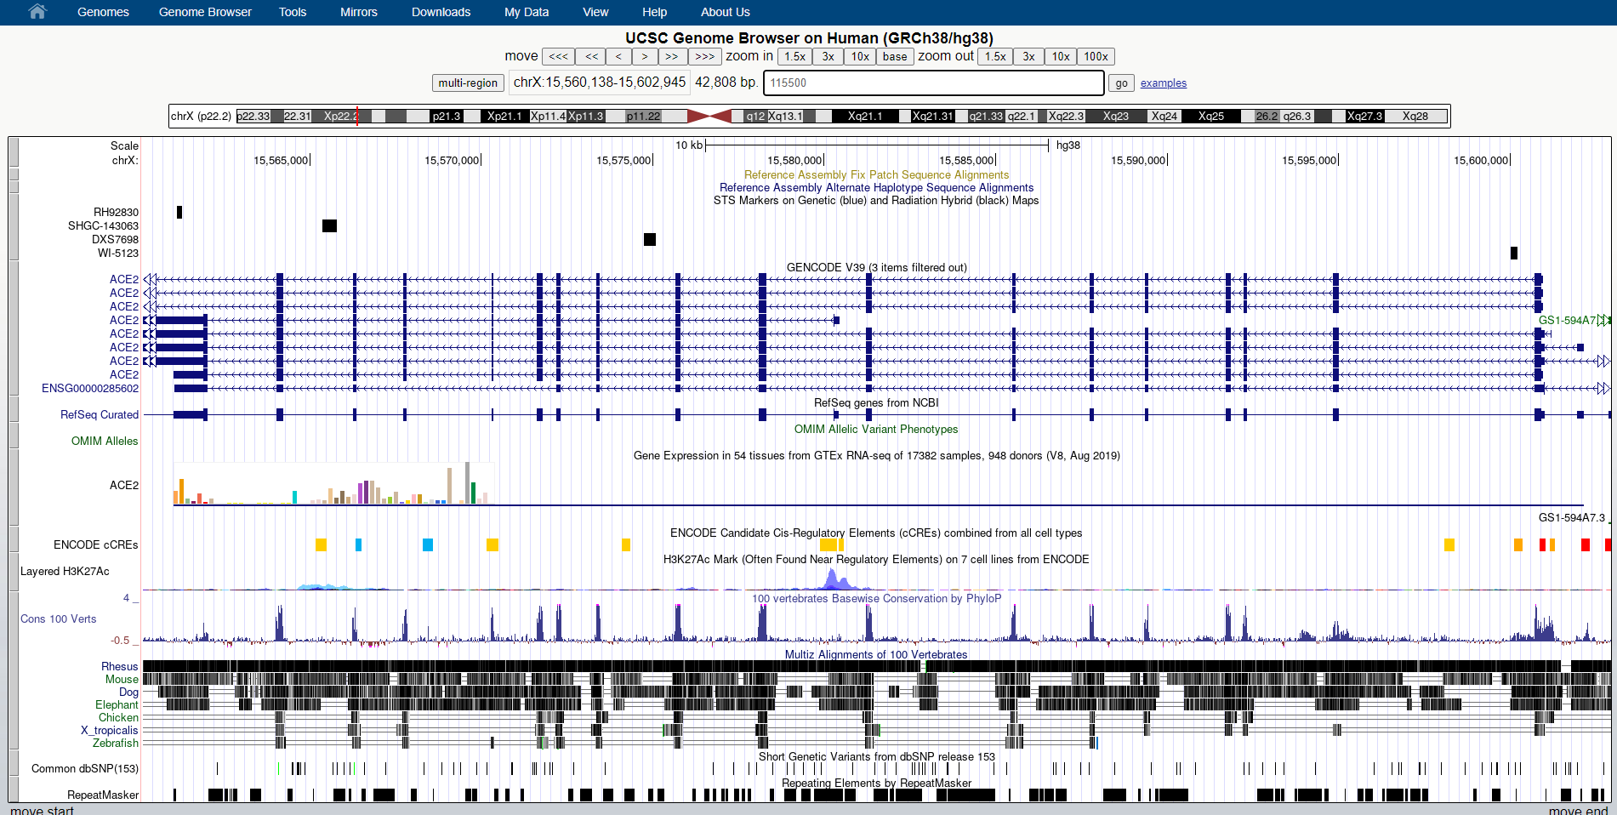**Fig6. Navigation by OMIM id: 115500**

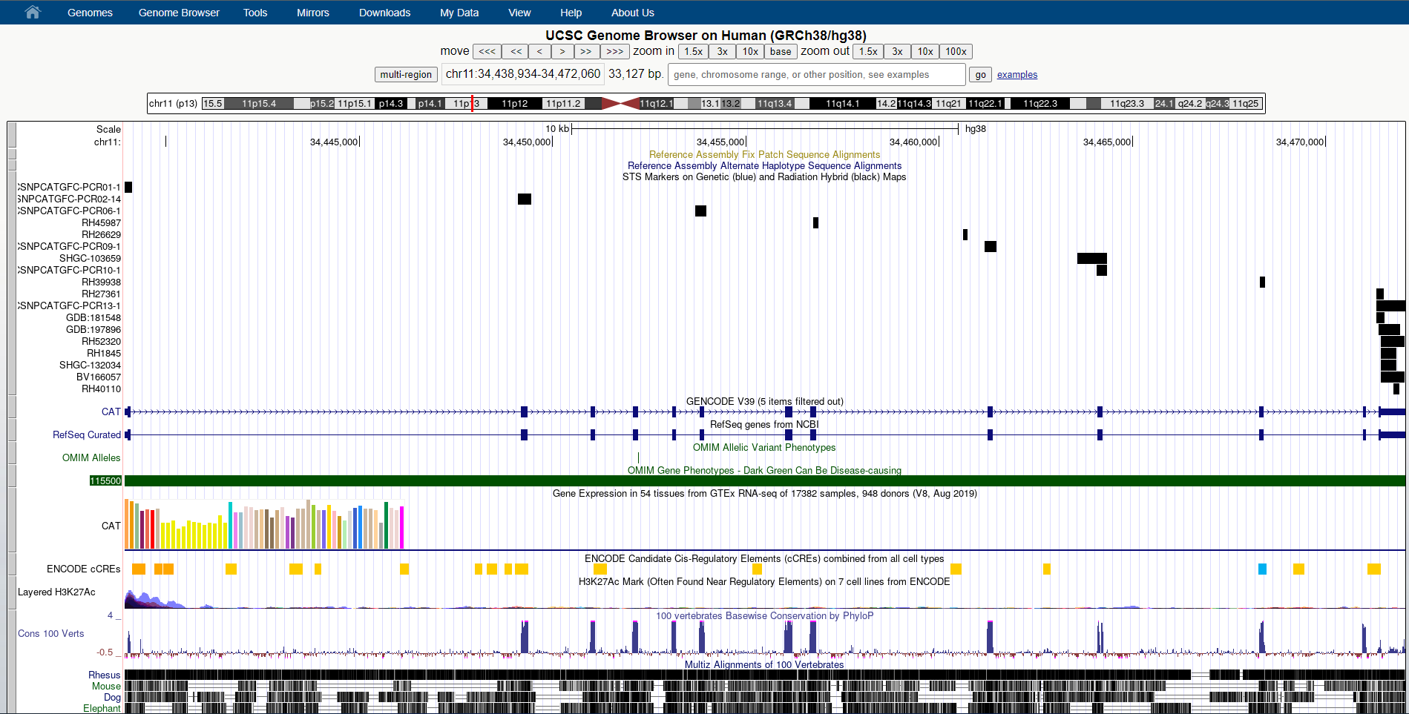**Fig7. Results for OMIM id: 115500**

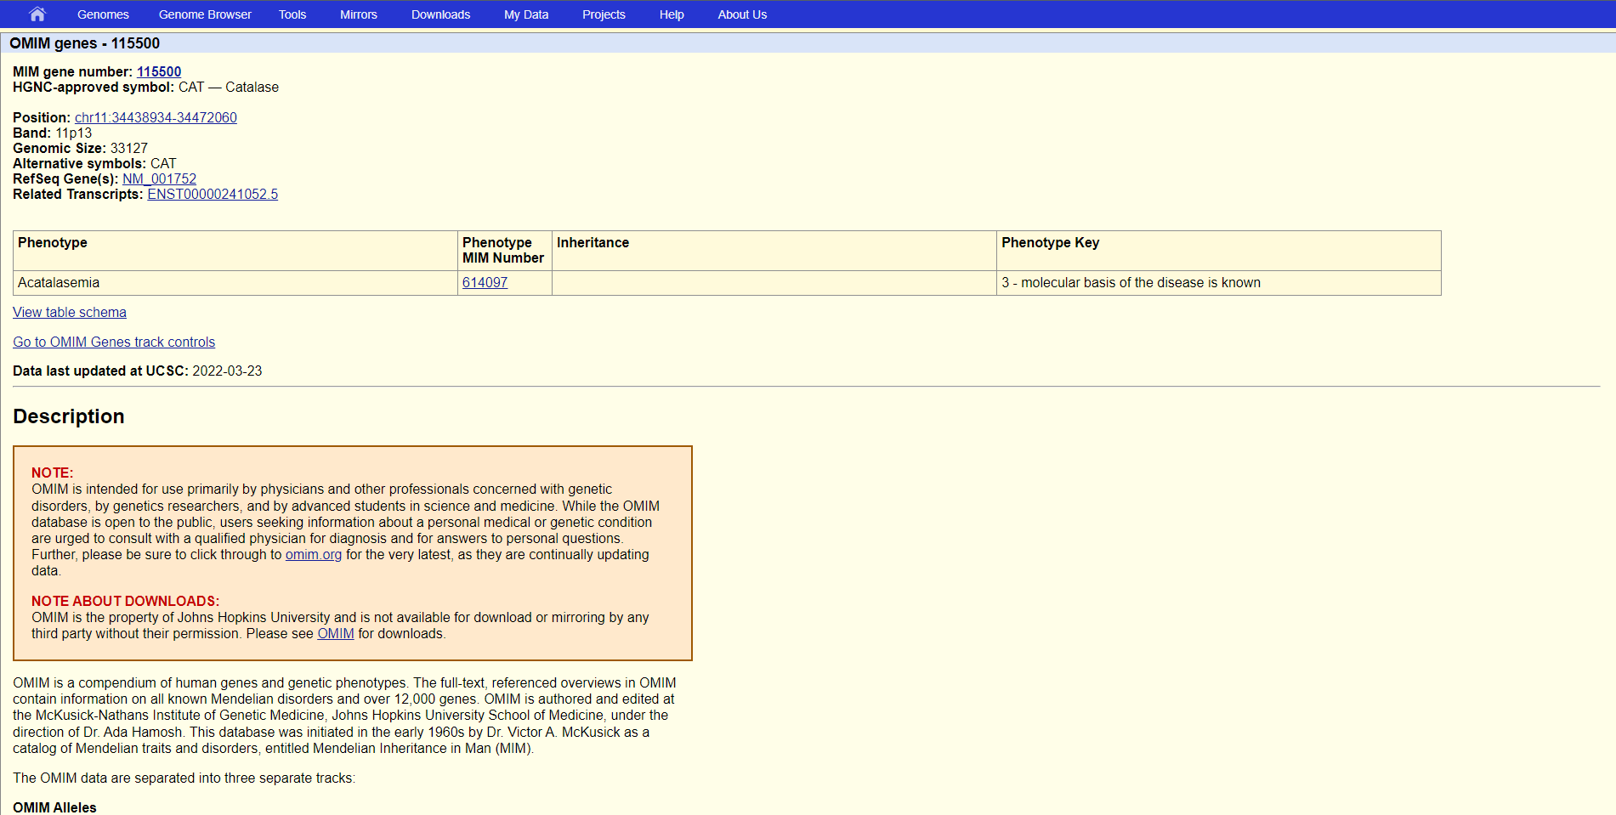**Fig8. Description for OMIM gene**

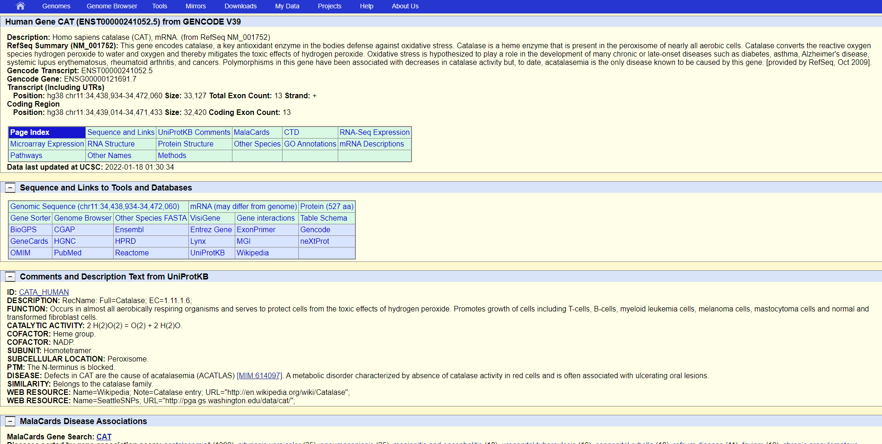**Fig9. Related transcripts information**

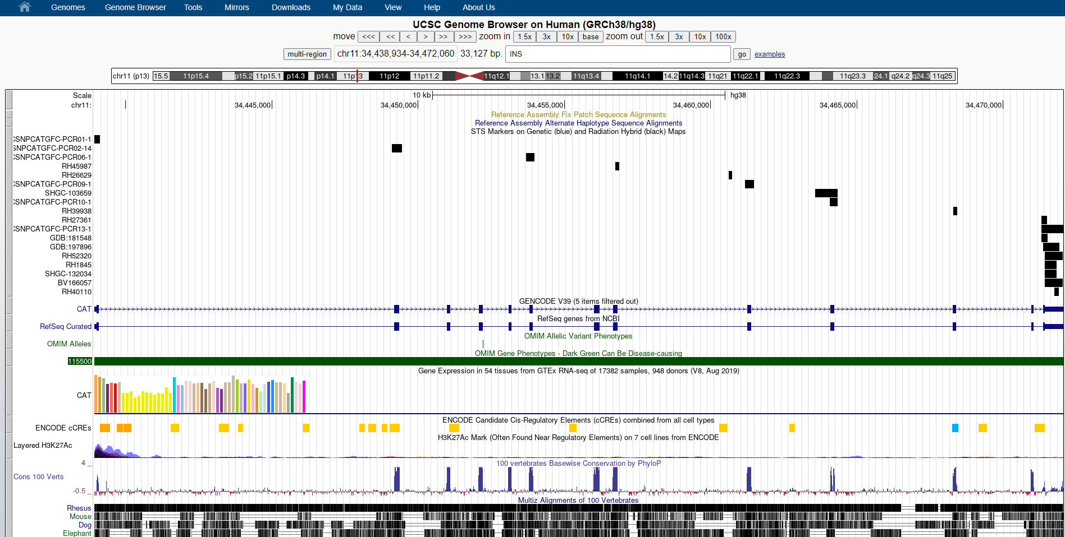**Fig10. Navigation by gene name: INS**

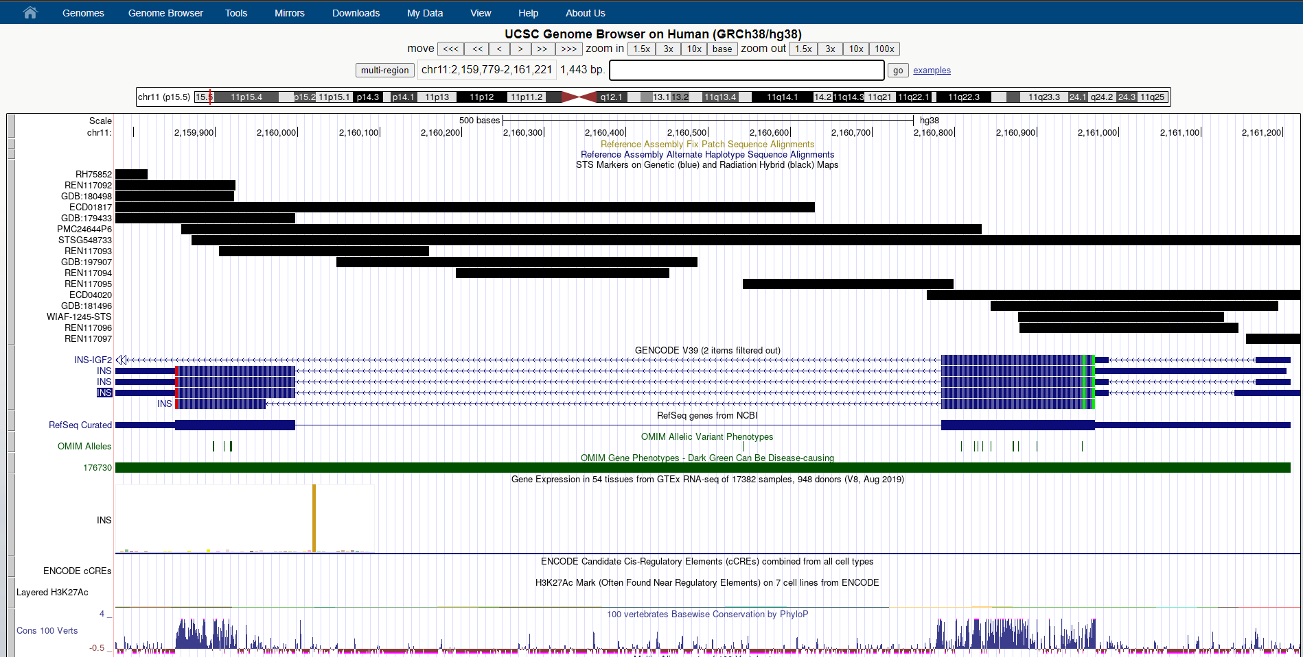**Fig11. Result for INS gene**

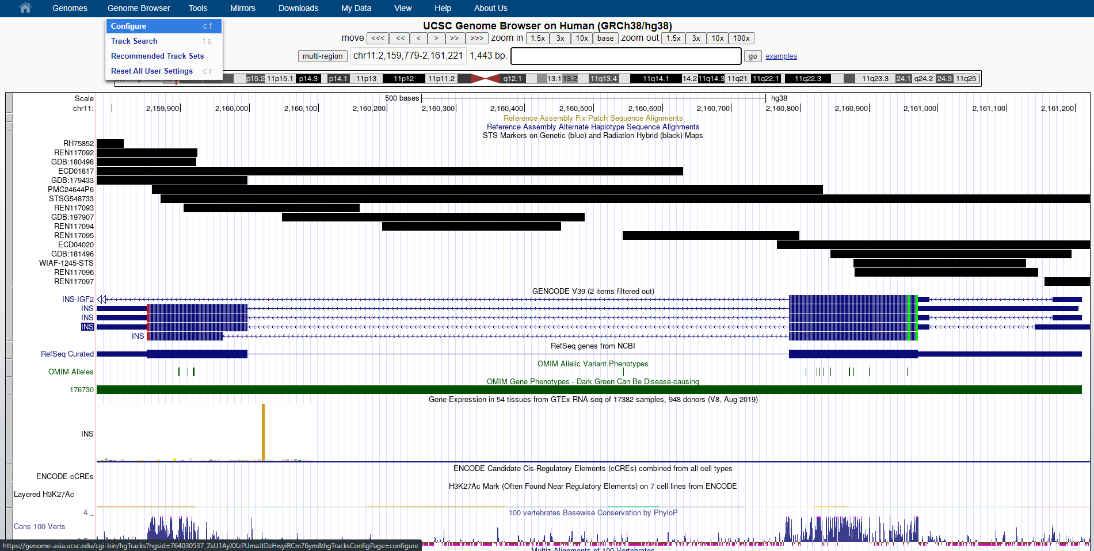**Fig12. Option to configure tracks**

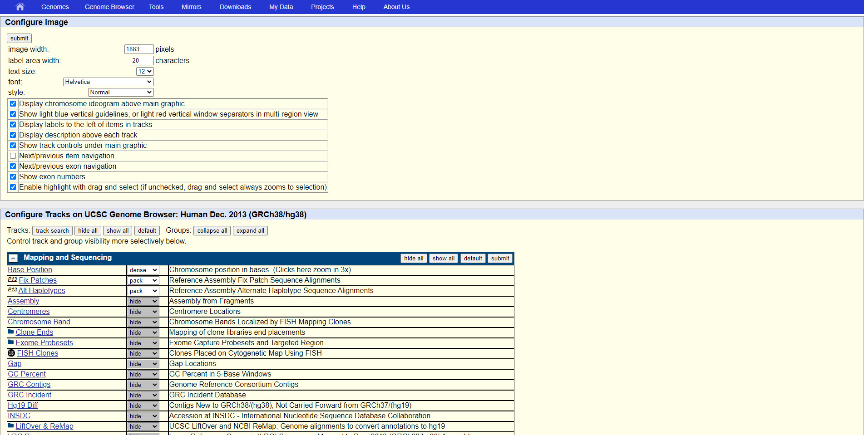**Fig13. Configuration settings**

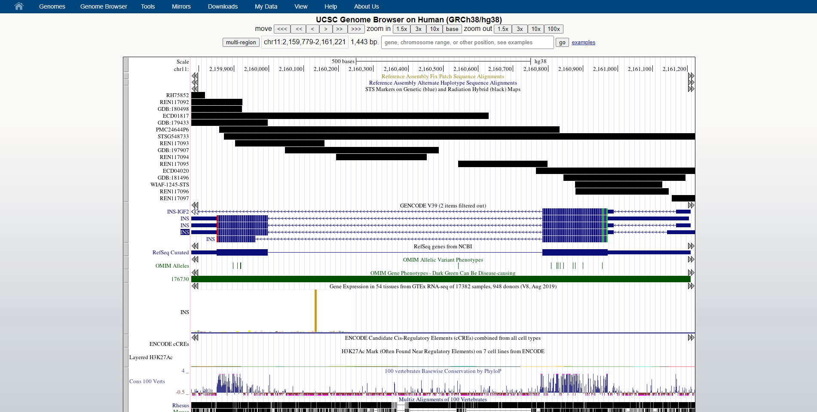**Fig14. Configured tracks**

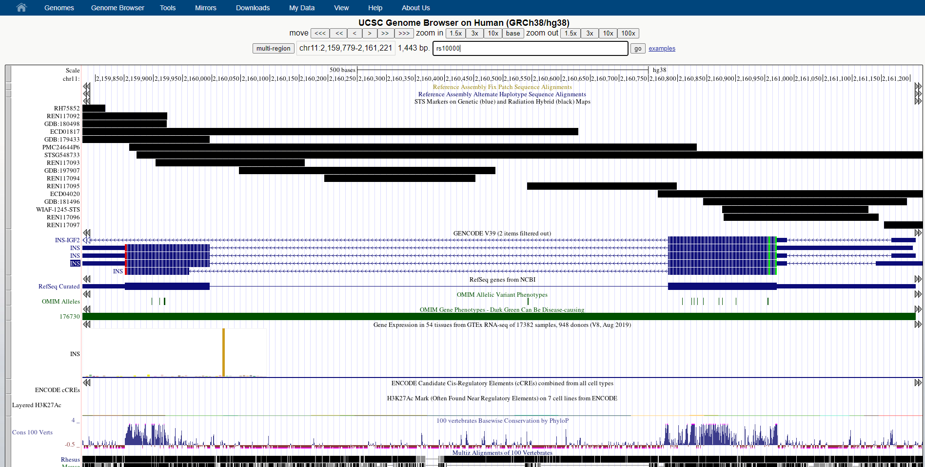**Fig15. Navigation by SNP id: rs10000**

**Fig16. Result for SNP id: rs10000**

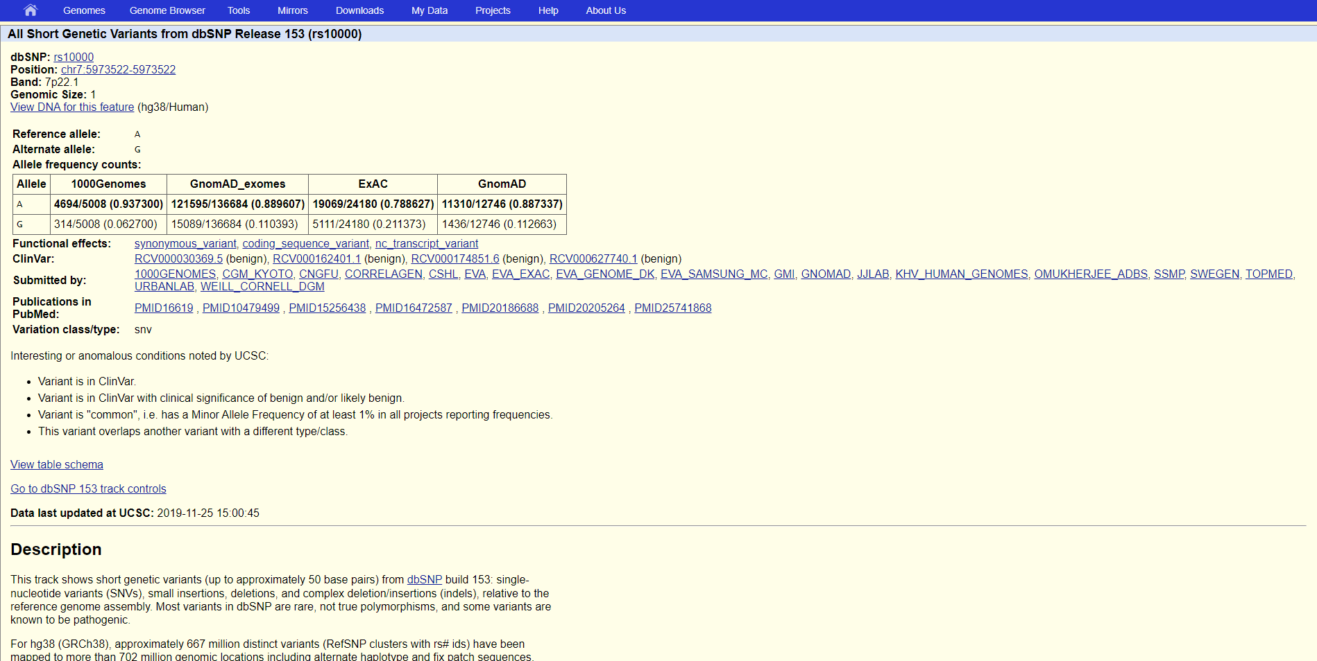**Fig17. Description for SNP id: rs10000**

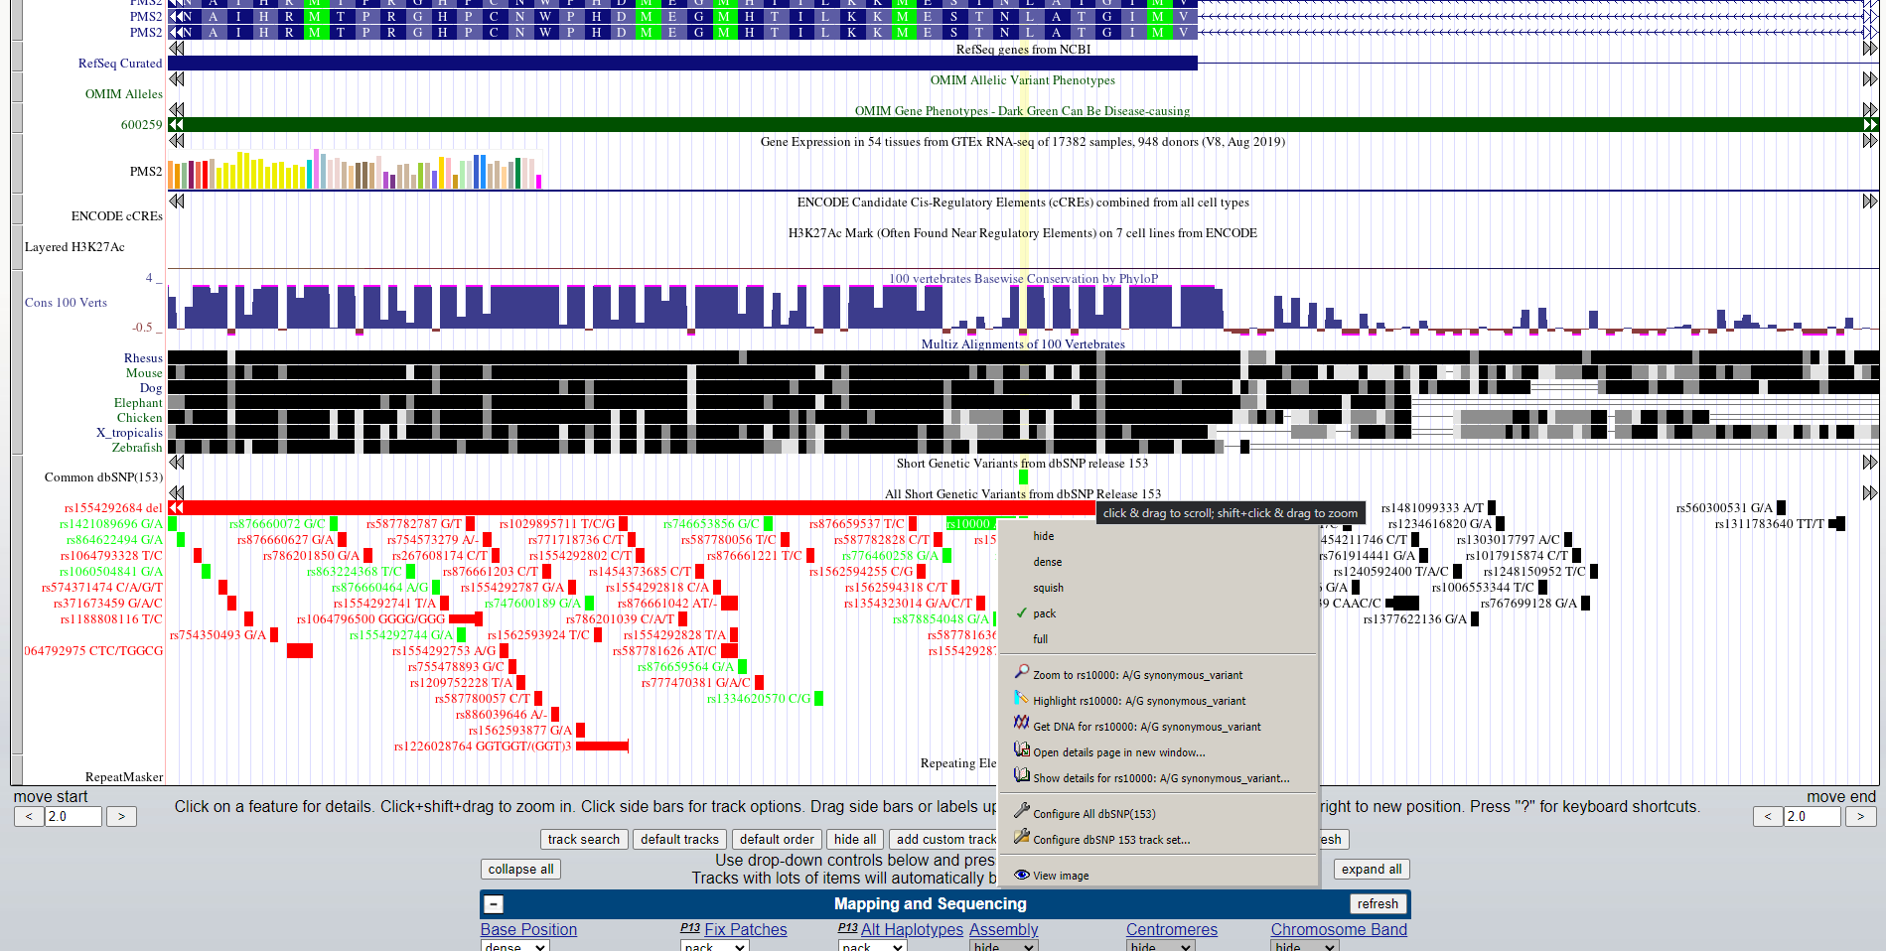**Fig18. Configuration option by right click**

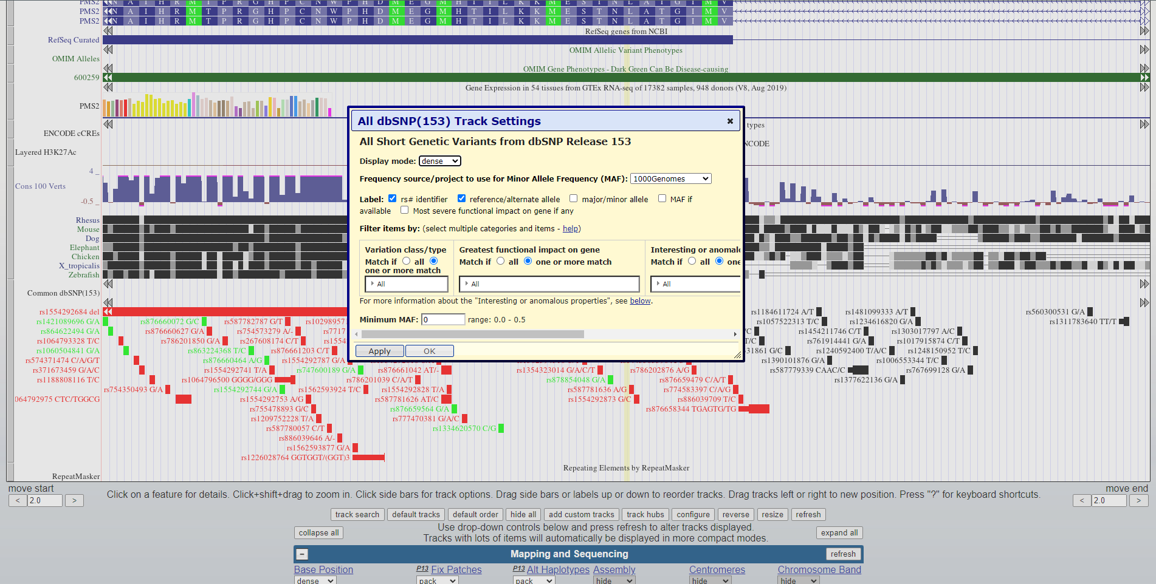**Fig19. Configuration applied**

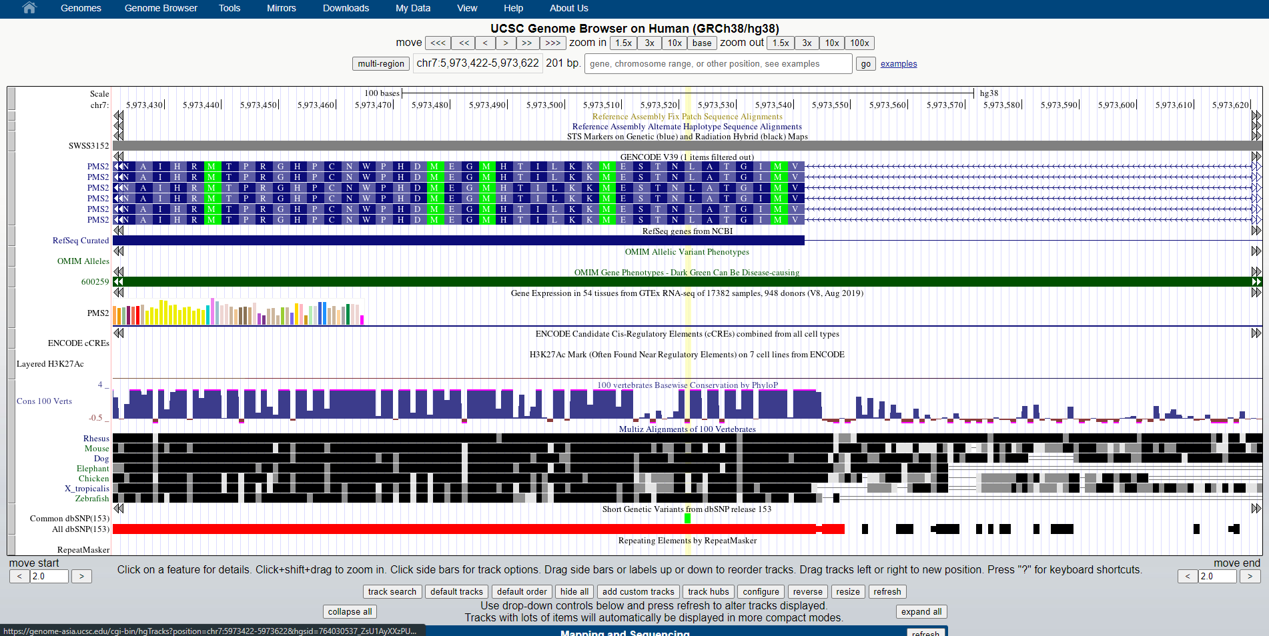**Fig20. Result after configuration**

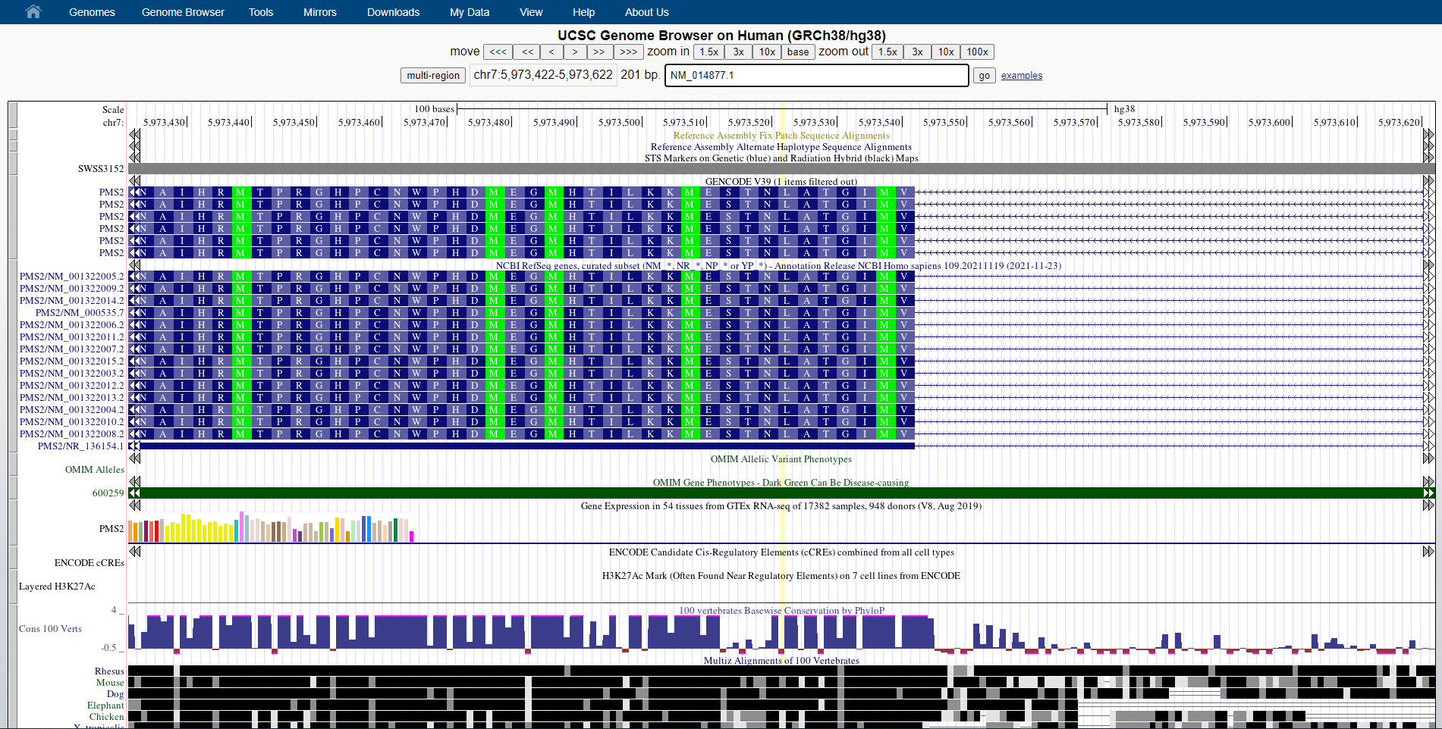**Fig21. Navigation by Ref_Seq: NM_014877.1 (HEL gene)**

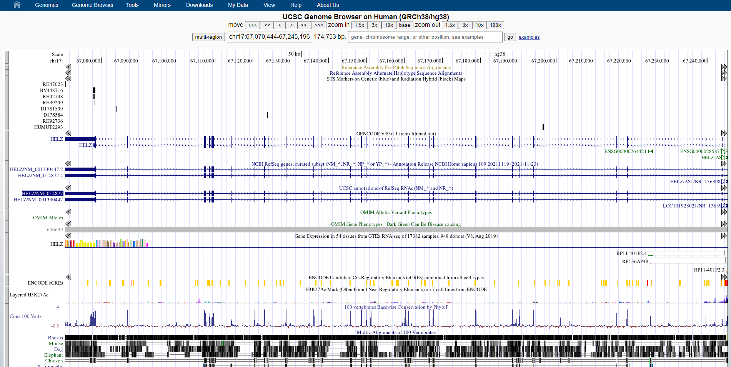**Fig22. Result for Ref_Seq: NM_014977.1 (HELZ gene)**

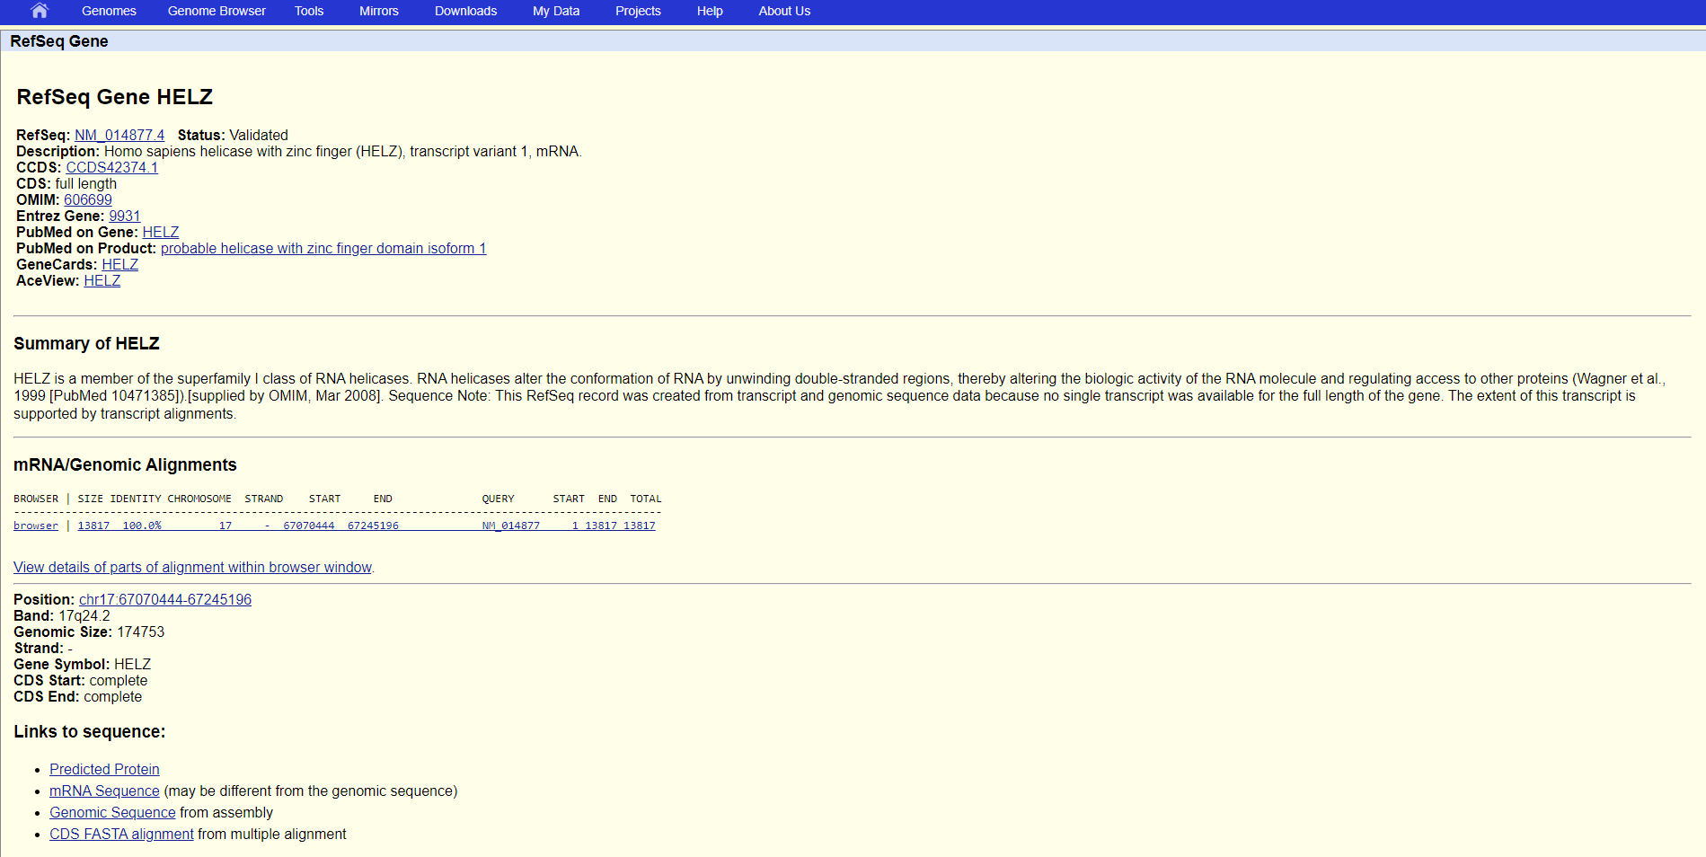**Fig23. Description for Gene HELZ**

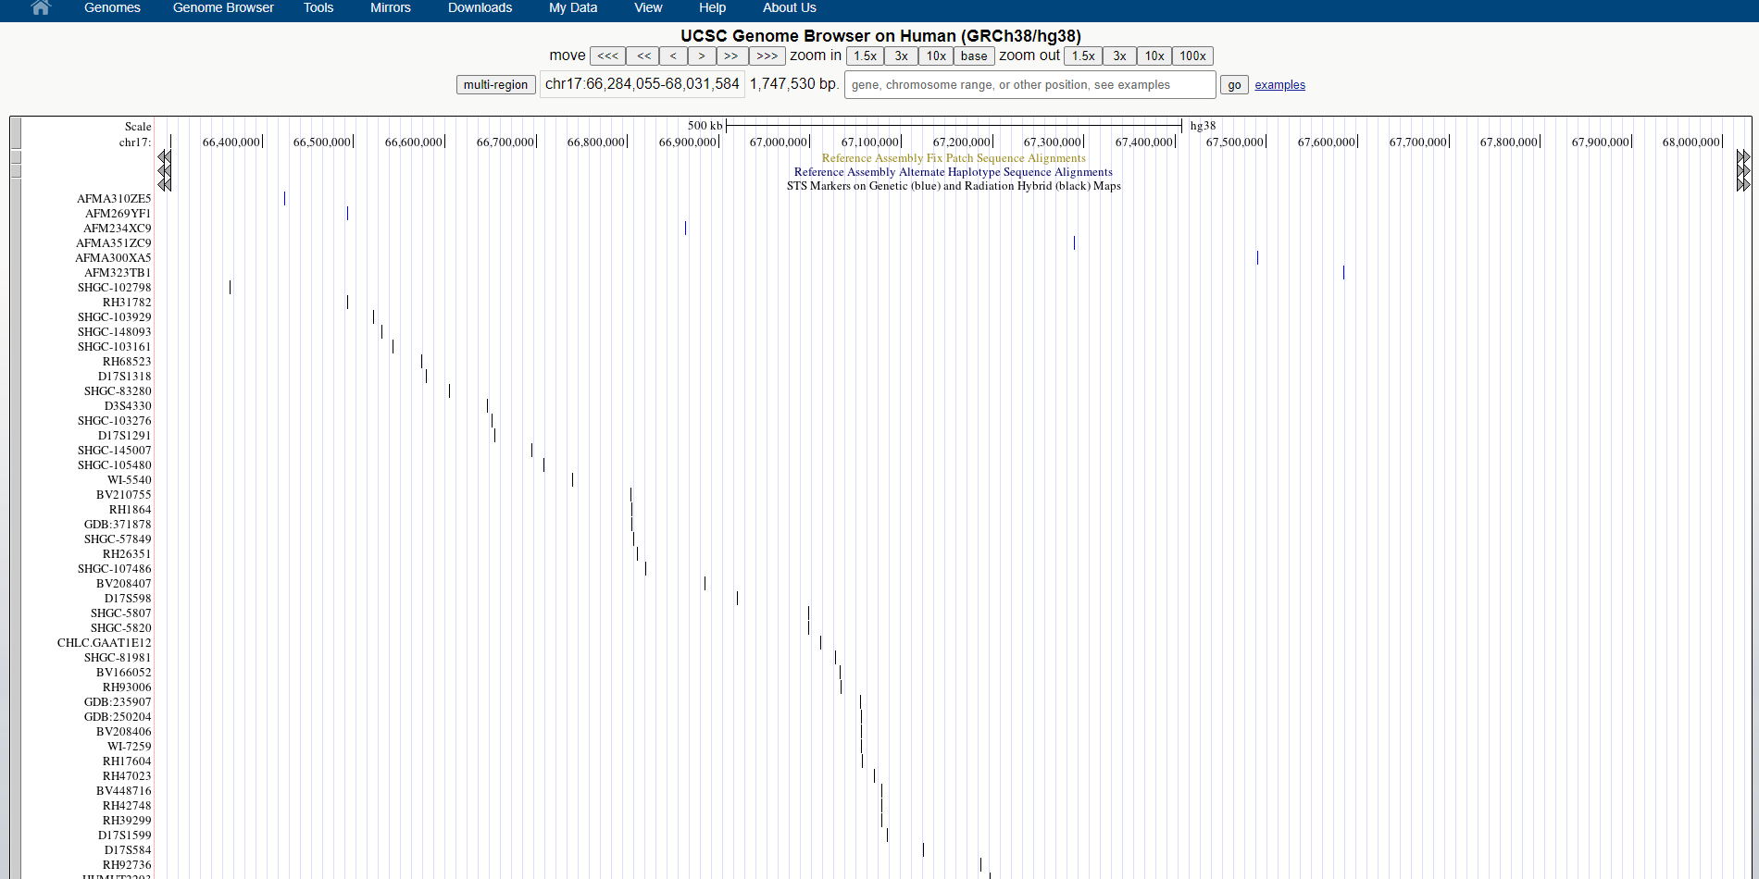**Fig24. Result after zooming 10x**

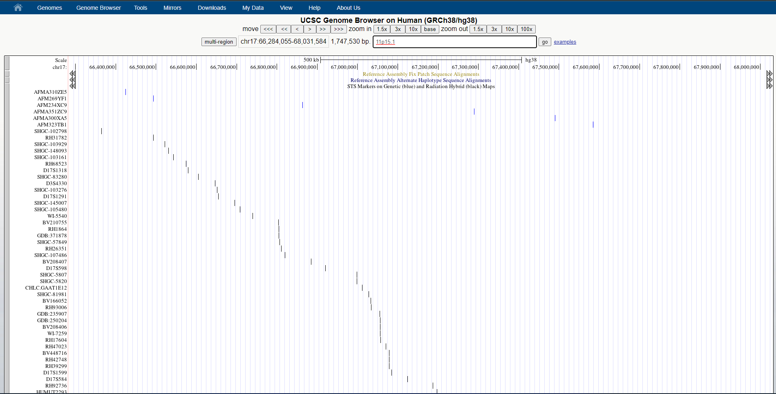**Fig25. Navigation by cytological band: 11p15.1**

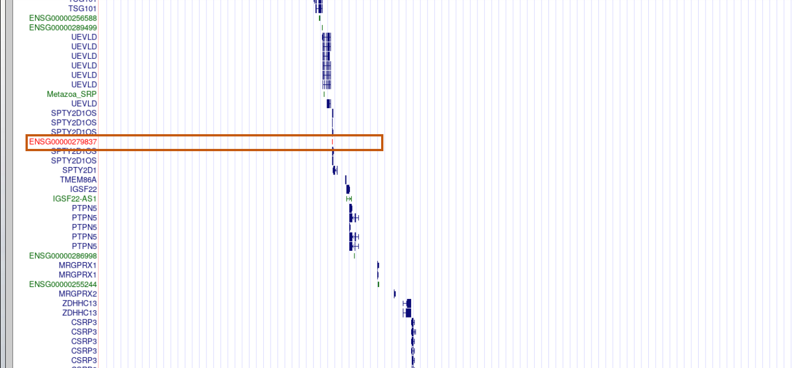**Fig26. Result for cytological band**

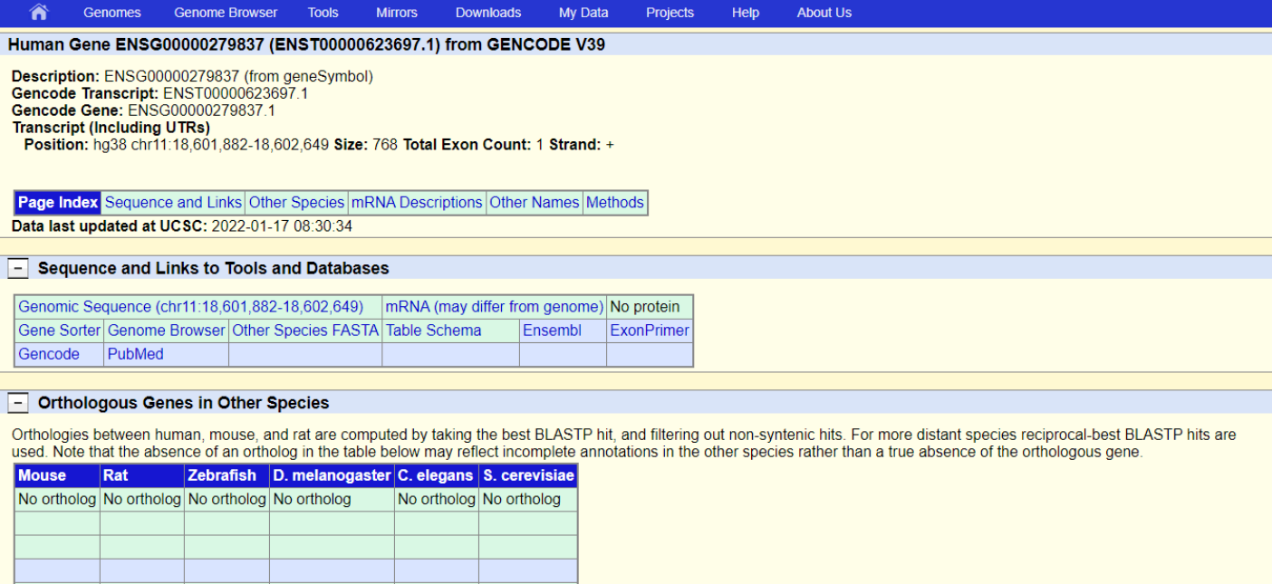**Fig27. Description for cytological ban: 11p15.1**

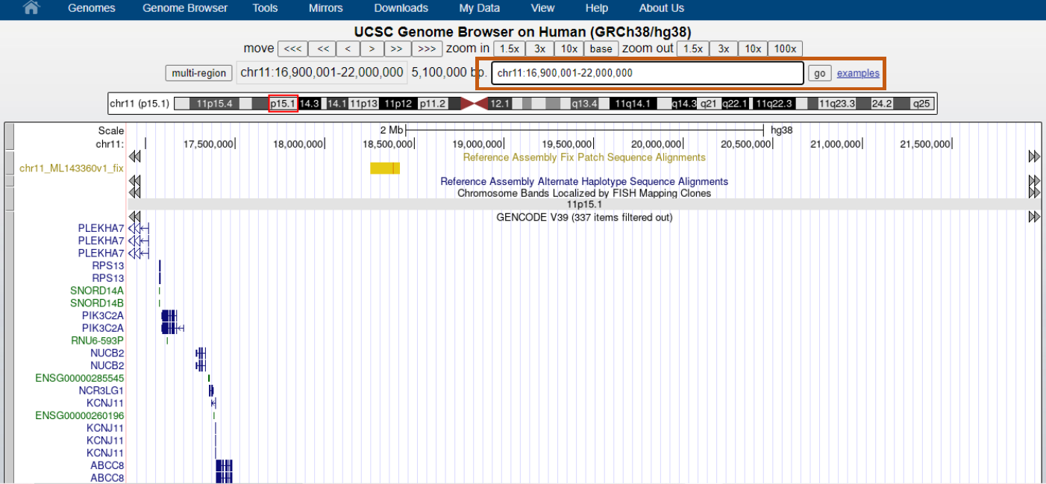**Fig28. Navigation by coordinates**

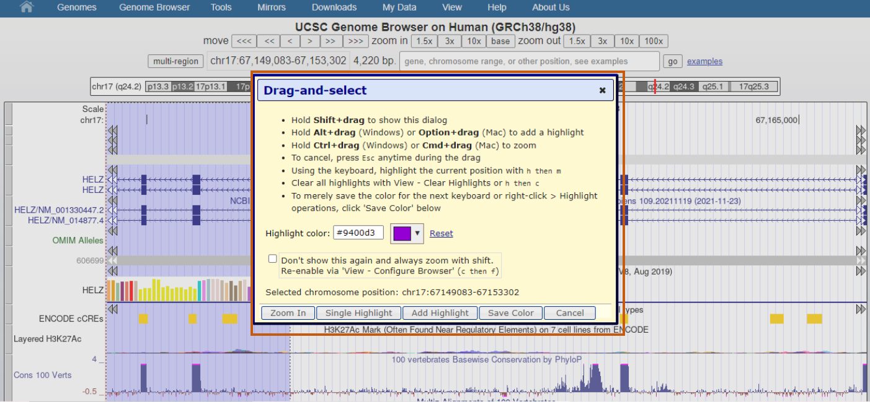**Fig29. Drag and select option for configuration**

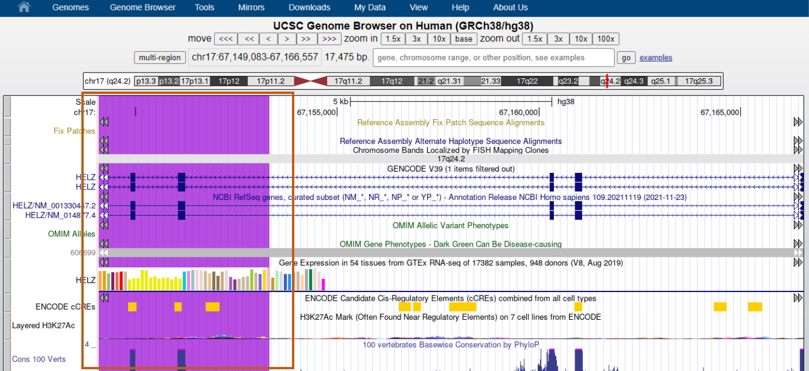**Fig30. Result after configuration**

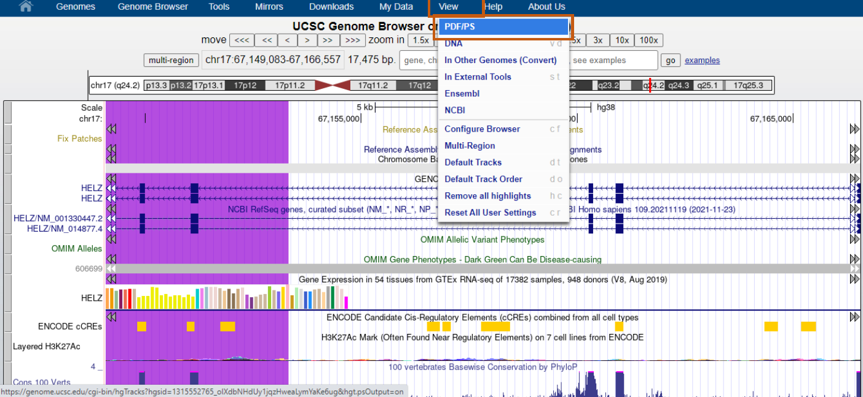**Fig32. Steps to export result as PDF**

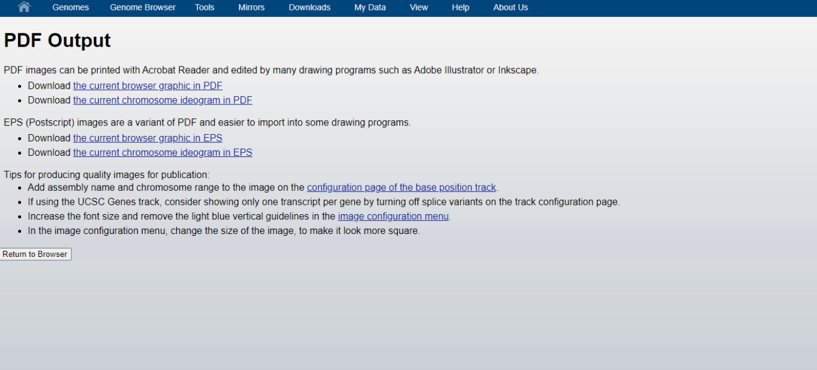**Fig33. Option to download PDF**

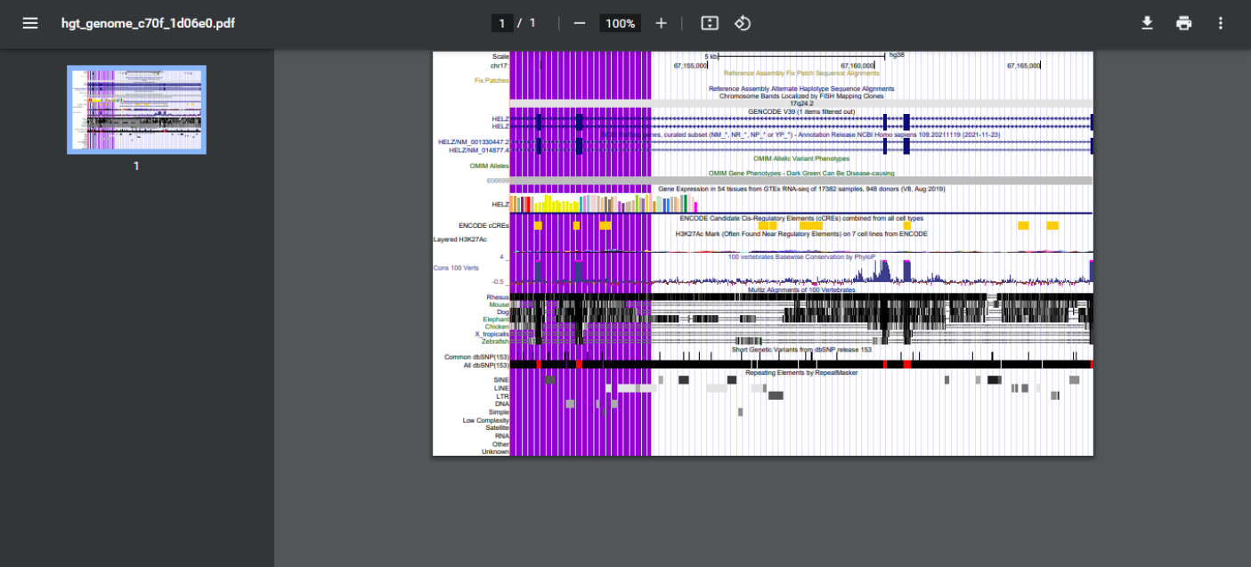**Fig34. Result in PDF format**

**RESULT:**

UCSC genome browser was used for setting for GRCH/hg38 browser and search option used were:

* Navigation by gene name
* Navigation by SNP id
* Navigation by Ref_Seq: NM_014877.4
* Navigation by OMIM Id: 115500
* Navigation by cytological band: 11p15.1

Various options for configuration of tracks, zooming in and out the results, saving results in PDF format, etc were also used.

**CONCLUSION:**

UCSC genome browser can be used for gene predictions, mRNA and expressed sequence tag alignments, simple nucleotide polymorphisms, expression and regulatory data, phenotype and variation data, and pairwise and multiple-species comparative genomics data. All information relevant to a region is presented in one window, facilitating biological analysis and interpretation. It also provides various tools for configuration of tracks and refining the results. Options are available for zooming in and out the results and downloading the results in PDF format.

**REFERENCES:**

1. Baxevanis, Andreas D.; Petsko, Gregory A.; Stein, Lincoln D.; Stormo, Gary D. (2002). Current Protocols in Bioinformatics || The UCSC Genome Browser. , (), –. doi:10.1002/0471250953.bi0104s28
2. UCSC Genome Browser Home. (2019). Ucsc.edu. Retrieved March 28, 2022, from <https://genome.ucsc.edu/>
3. UCSC Genome Browser Gateway. (2018). Ucsc.edu. Retrieved March 28, 2022, from <https://genome.ucsc.edu/cgi-bin/hgGateway>
4. Human hg38 chr11%3A34438934%2D34472060 UCSC Genome Browser v428. (n.d.).Genome.ucsc.edu. Retrieved March 28, 2022, from <https://genome.ucsc.edu/cg/bin/hgTracks?db=hg38&lastVirtModeType=default&lastVirtModeExtraState=&virtModeType=default&virtMode=0&nonVirtPosition=&position=chr11%3A34438934%2D34472060&hgsid=1315552765_oIXdbNHdUy1jqzHweaLymYaKe6ug>
5. **Navigation by OMIM id:** OMIM genes - 115500. (n.d.). Genome.ucsc.edu. Retrieved March 28, 2022, from <https://genome.ucsc.edu/cgi-bin/hgc?hgsid=1315629613_43o3KD070AuOsLgYd19FgktiKt2H&db=hg38&c=chr11&l=34438933&r=34472060&o=34438933&t=34472060&g=omimGene2&i=115500>
6. **Navigation by SNP id:** All Short Genetic Variants from dbSNP Release 153 (rs10000). (n.d.). Genome.ucsc.edu. Retrieved March 28 2022, from <https://genome.ucsc.edu/cgi-bin/hgc?hgsid=1315552765_oIXdbNHdUy1jqzHweaLymYaKe6ug&db=hg38&c=chr7&l=5973421&r=5973622&o=5973521&t=5973522&g=dbSnp153&i=rs10000>
7. **Navigation by Ref_Seq:** NCBI RefSeq genes, curated subset (NM_*, NR_*, NP_* or YP_*) - NM_014877.4. (n.d.).Genome.ucsc.edu. Retrieved March 28, 2022, from <https://genome.ucsc.edu/cgibin/hgc?hgsid=1315552765_oIXdbNHdUy1jqzHweaLymYaKe6ug&db=hg38&c=chr17&l=67070443&r=67245196&o=67070443&t=67245196&g=ncbiRefSeqCurated&i=NM_014877.4>
8. **Navigation by Cytological band:** Human Gene ENSG00000279837 (ENST00000623697.1) from GENCODE V39. (n.d.)Genome.ucsc.edu. Retrieved March 28, 2022, from <https://genome.ucsc.edu/cgibin/hgGene?hgg_gene=ENST00000623697.1&hgg_chrom=chr11&hgg_start=18601881&hgg_end=18602649&hgg_type=knownGene&db=hg38>

**DATE: 30-03-22**

**WEBLEM 9b**

**Ensemble Genome Browser**

**(URL:** [**https://asia.ensemble.org/index.html**](https://asia.ensemble.org/index.html)**)**

**AIM:**

To explore Ensembl genome browser in order to gather information for annotated genes/genome/protein/transcript etc.

**INTROCUTION:**

**The Ensembl project** was initially launched in **1999** with the aim of **developing methodologies** for **automatic annotation** of (human) **genomic sequence** with genes and their **constituent transcripts**. Since that time, the project has broadened substantially in scope; the **Ensembl Genome Browser**, which came online in **2000**, now includes **reference genomic sequence** and **annotation** for nearly **100 chordate organisms**. Ensembl is **rapidly incorporating** new data, including **whole clades** of new species’ genomes and reference sequence for **multiple strains of existing species**, such as mouse. In addition, existing annotation is **regularly augmented** by the **inclusion of new data sets**. Ensembl’s sister site, **Ensembl Genomes**, provides access to **nonvertebrate genomes** through dedicated portals for **Bacteria, Fungi, Plants, Metazoa, and Protists.**

**METHODOLOGY:**

1. Open homepage for Ensembl genome browser. (URL: <https://asia.ensembl.org/index.html>)
2. Select human (GRCH38.p13) genome assembly
3. Search for helad1 gene.
4. Observer the results.
5. Use the configuration tools for the tracks.
6. Interpret the results.

**OBSERVATION:**

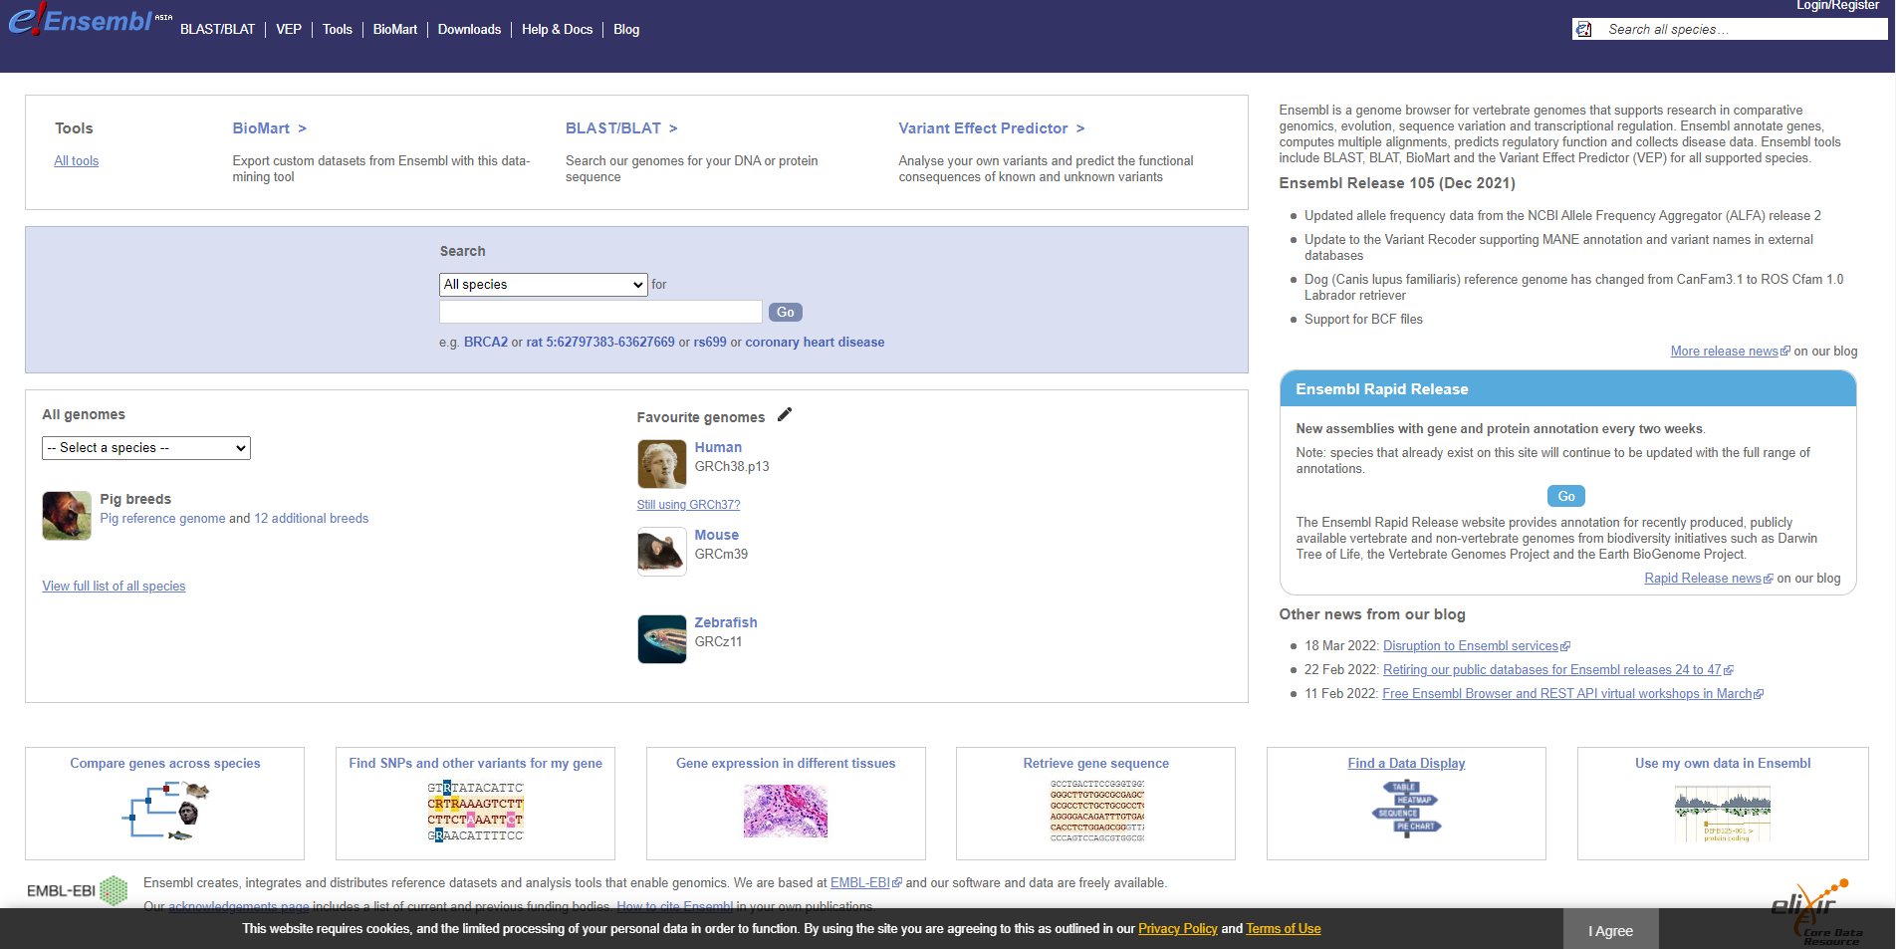**Fig1. Homepage for Ensembl**

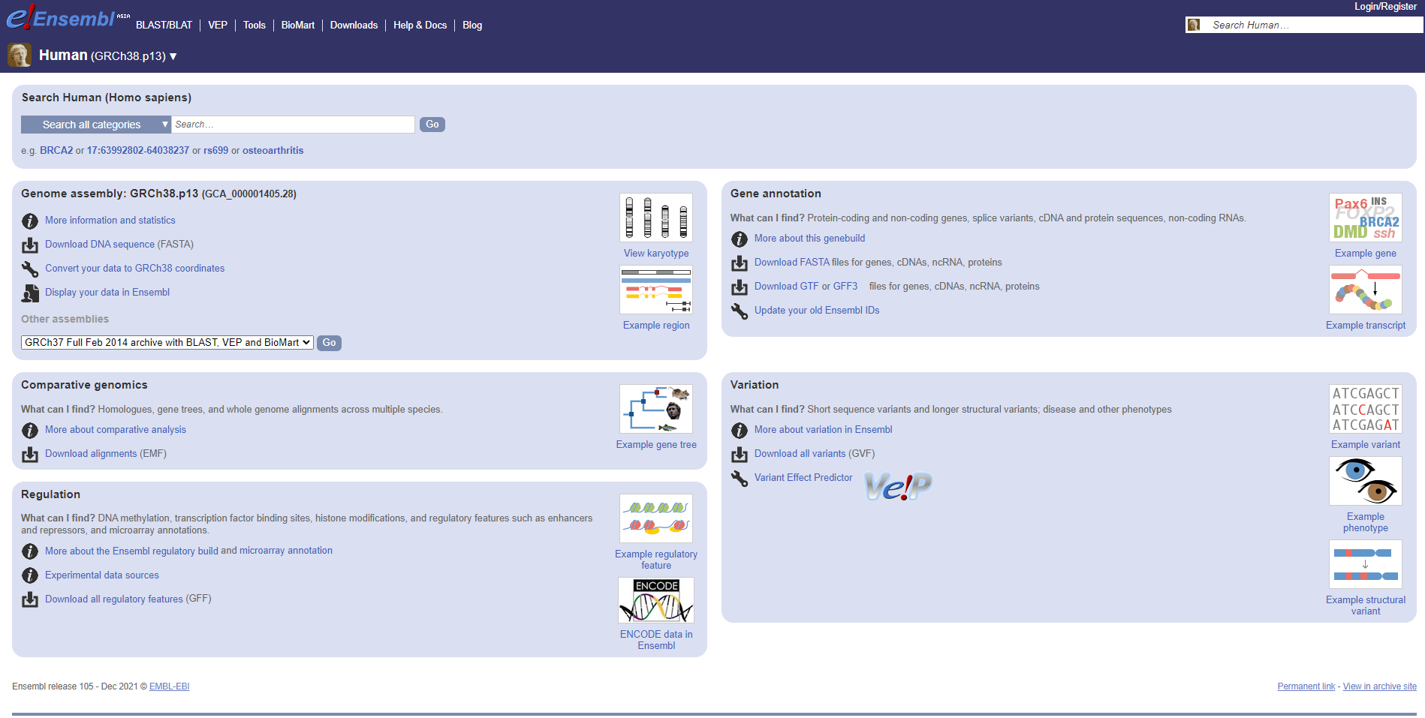**Fig2. Homepage for Human (GRCH28.p13) genome assembly**

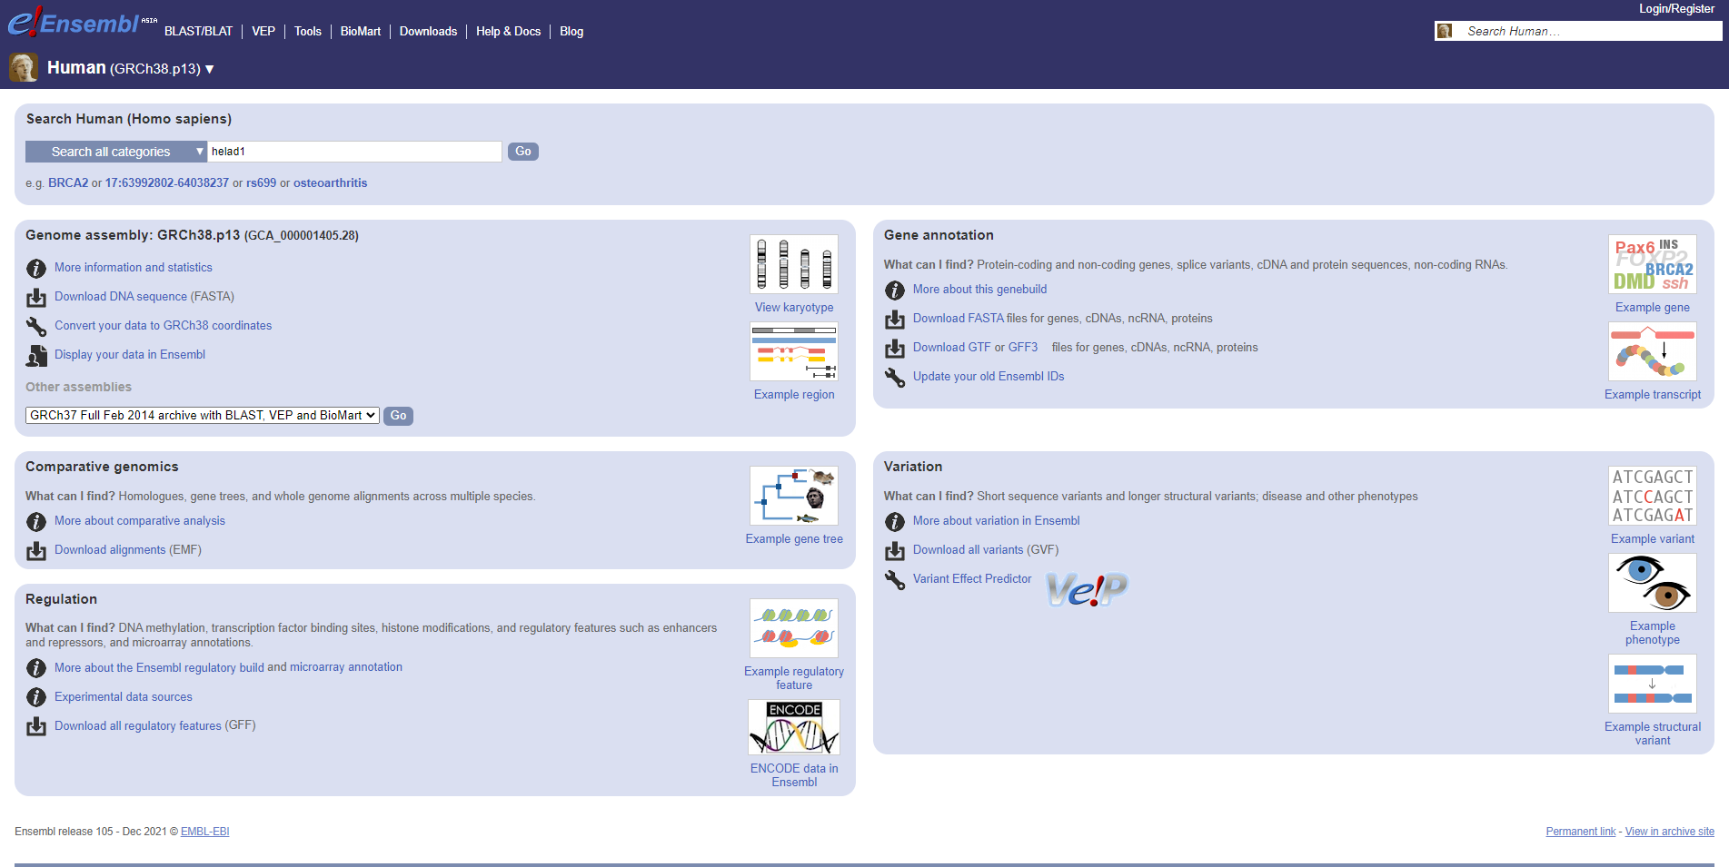**Fig3. Search for helad1 gene**

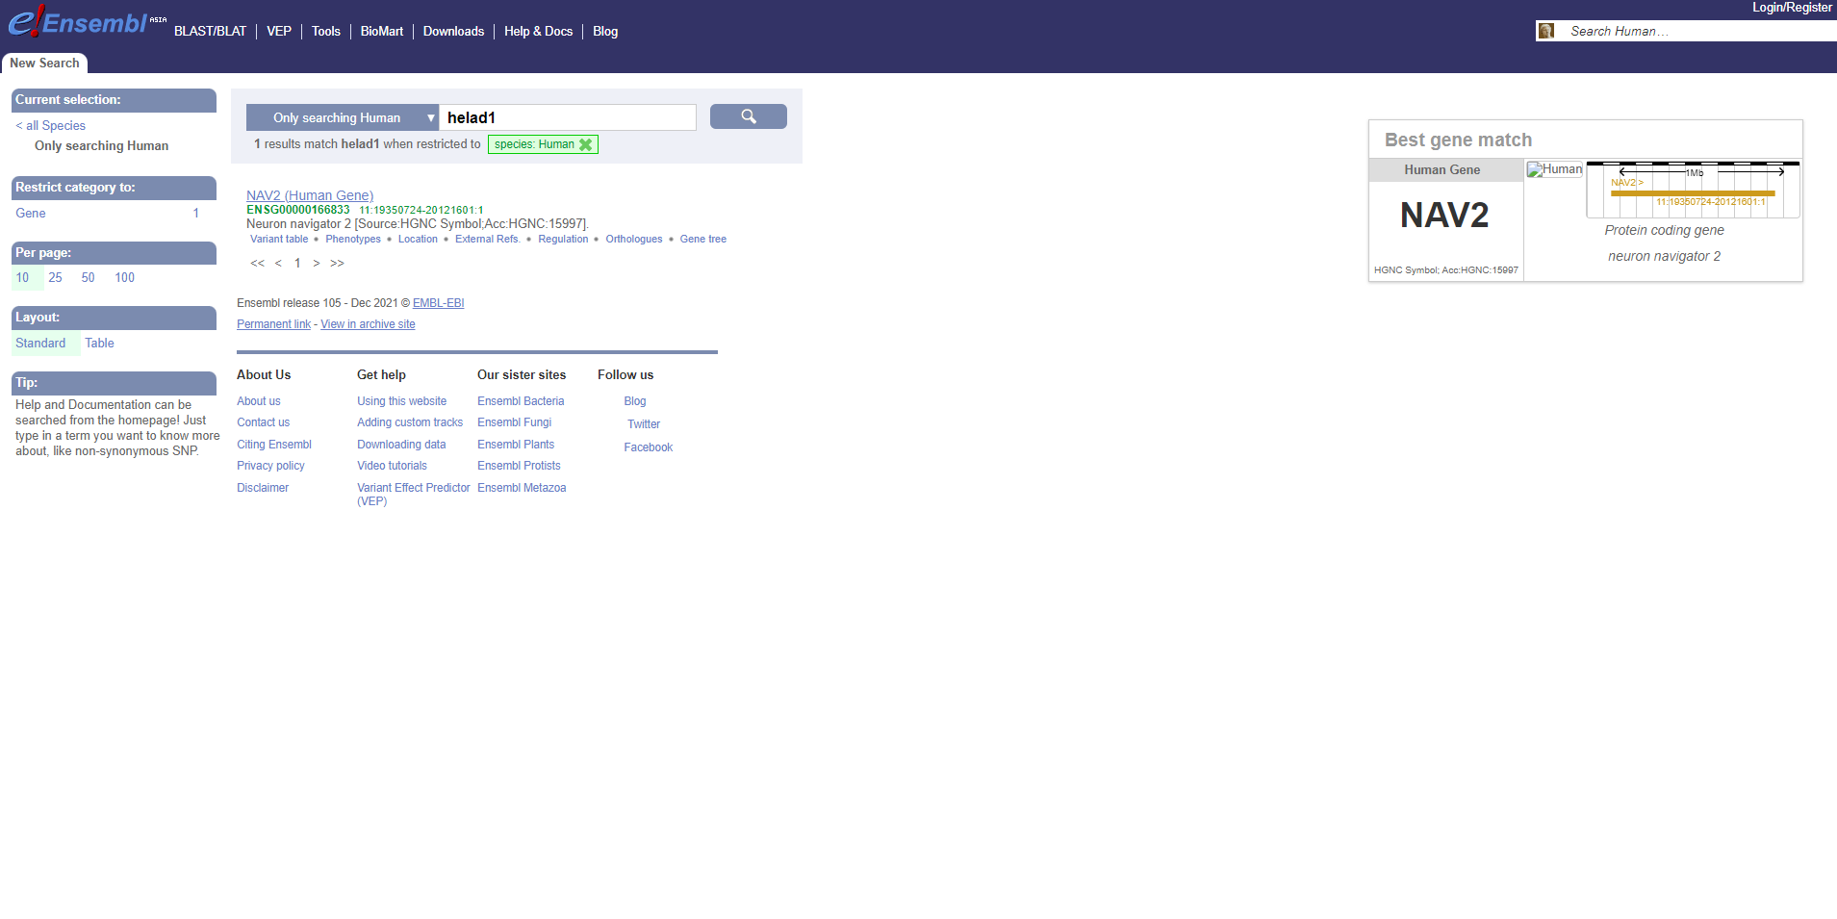**Fig4. Hit page for helad1 gene**

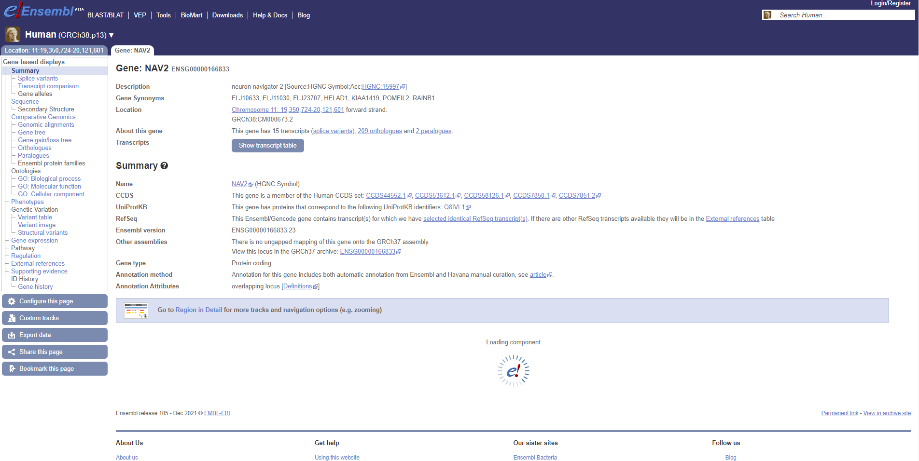**Fig5. Result for NAV2 gene**

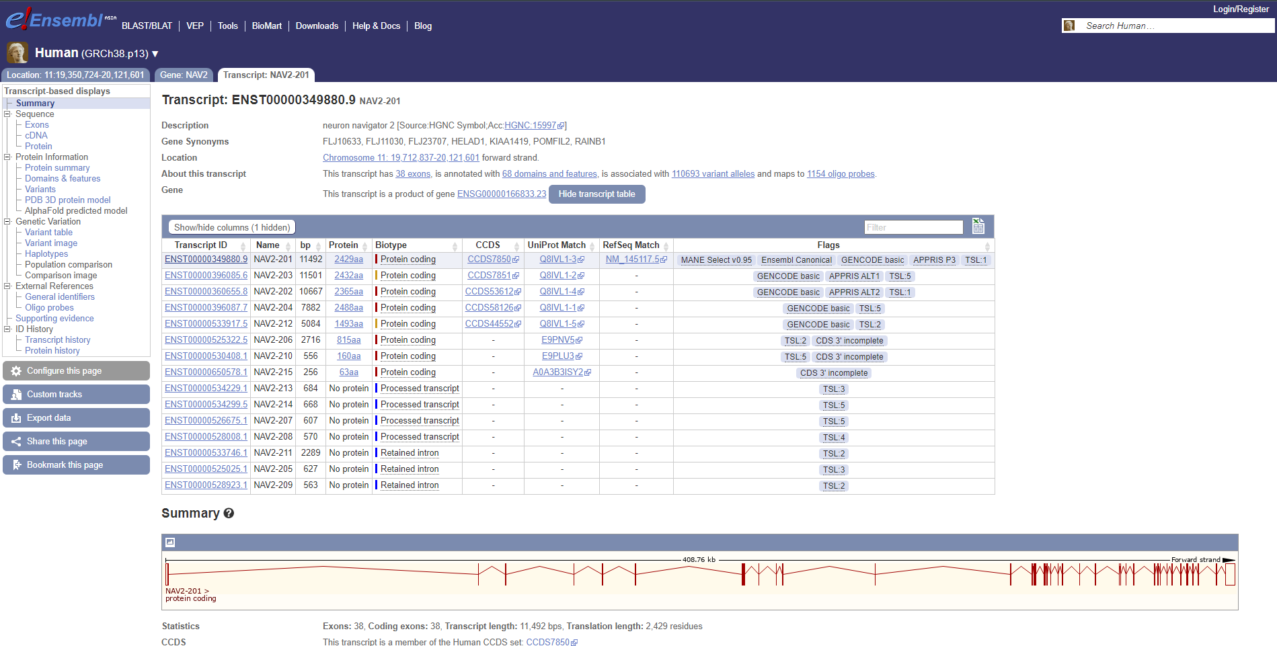**Fig6. Result for NAV2-201**

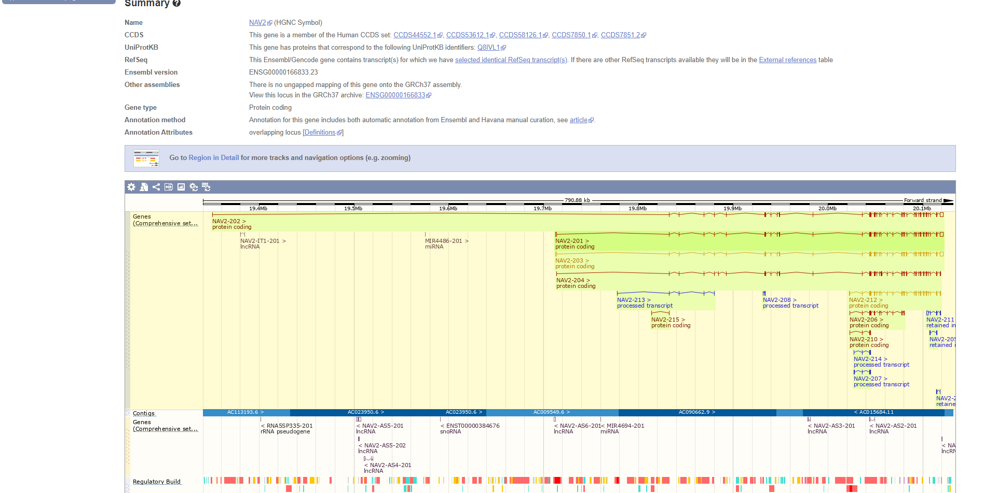**Fig7. Result for NAV2**

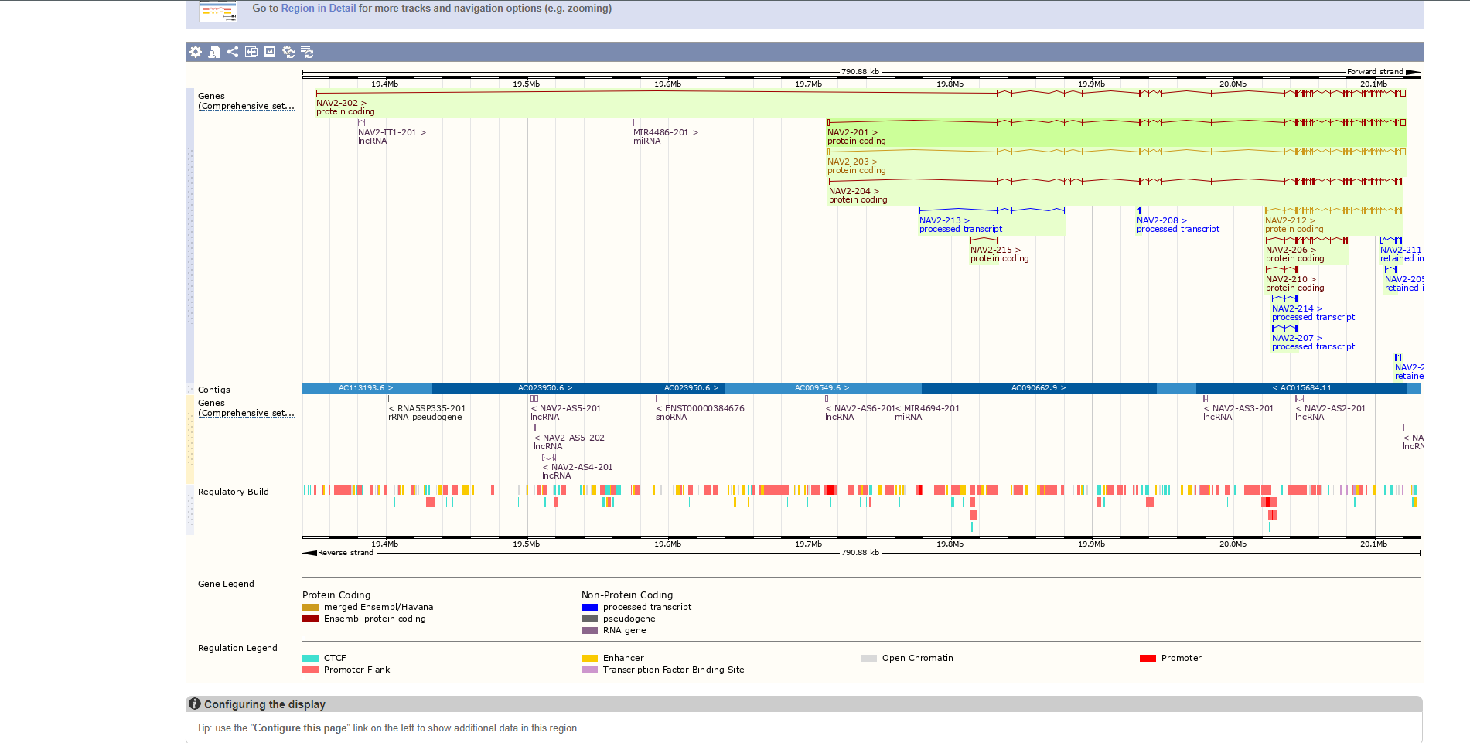**Fig6. Tracks information**

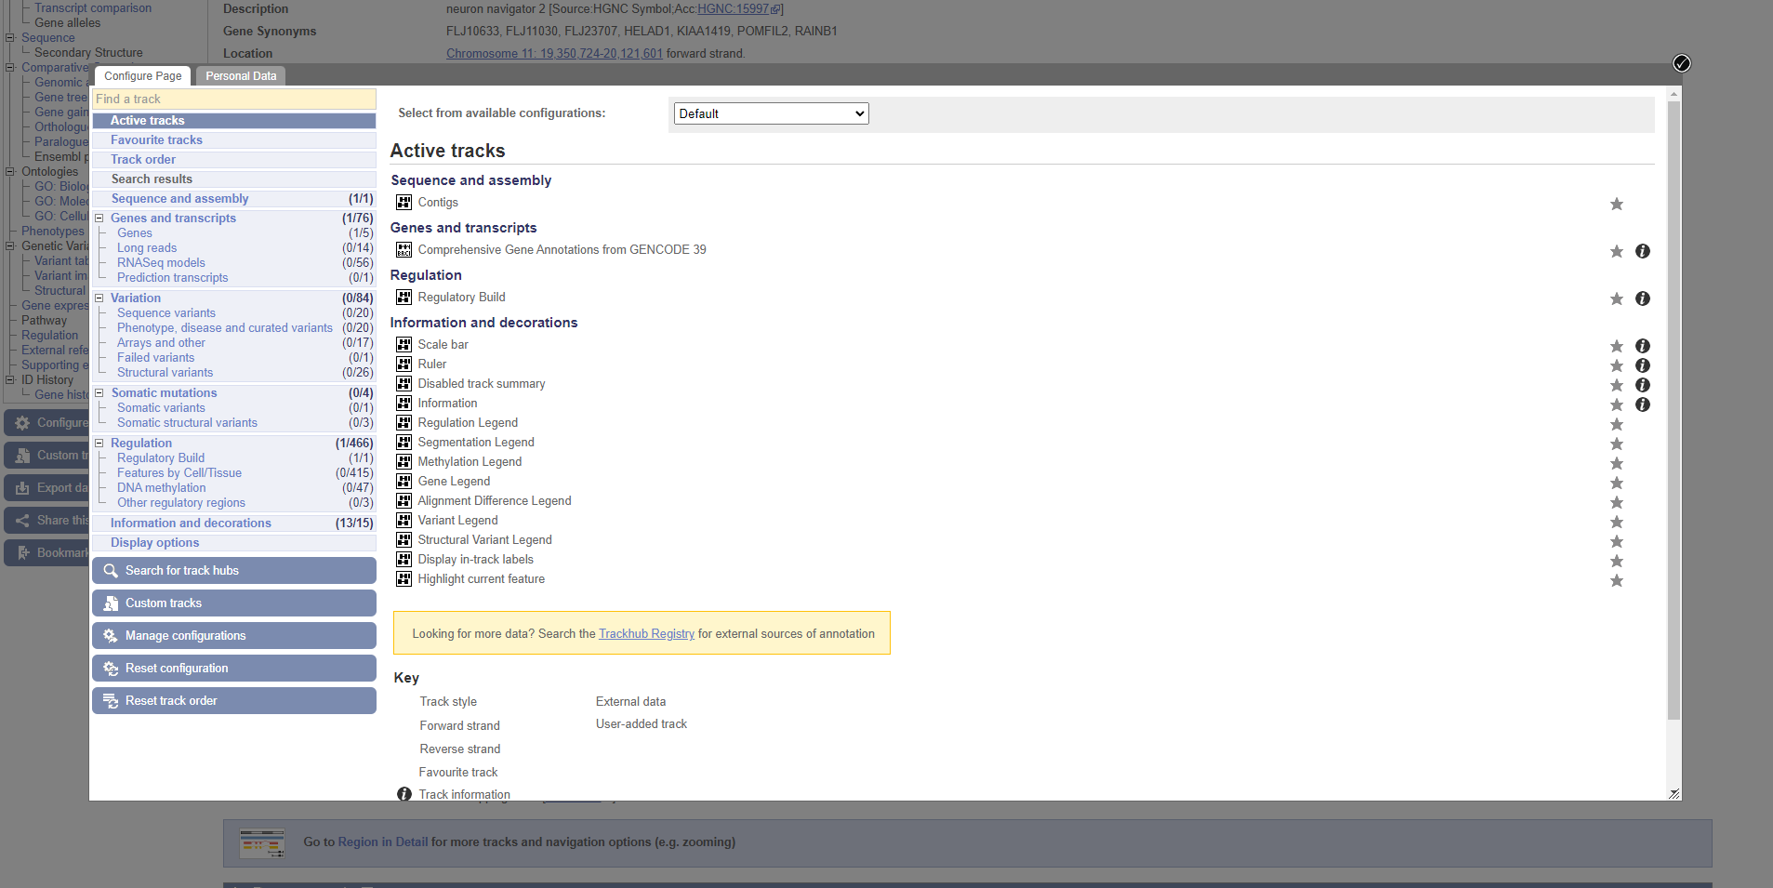**Fig7. Option for tracks configuration**

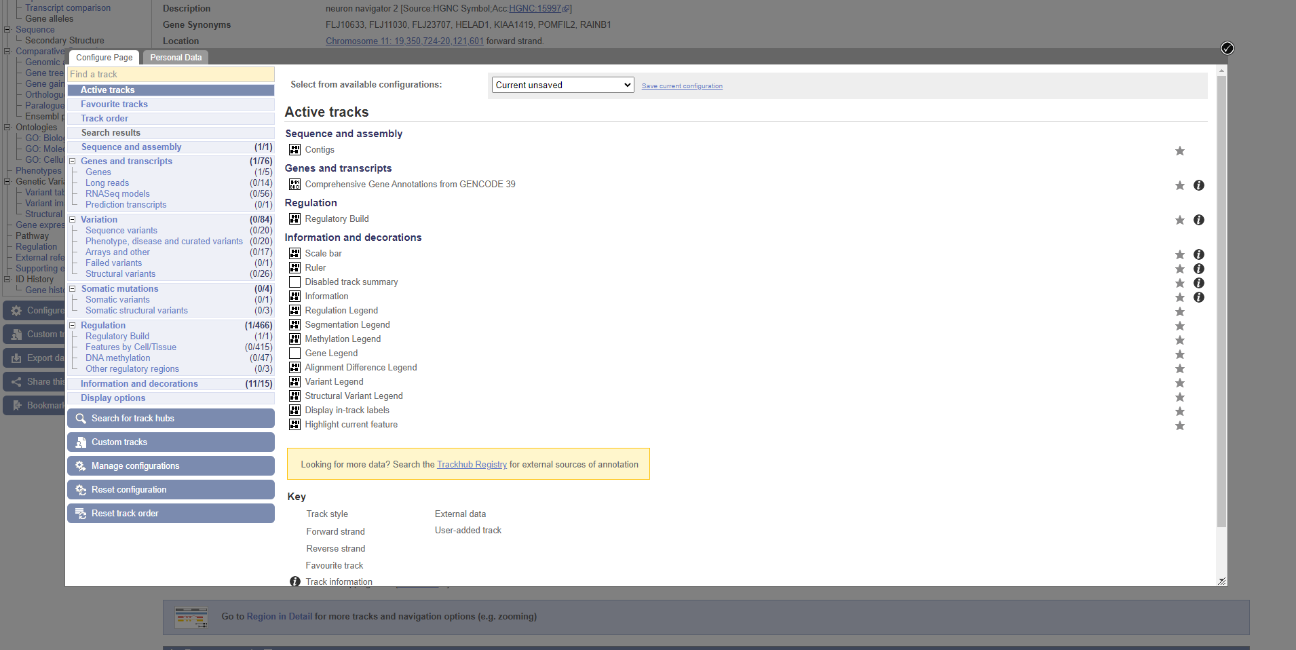**Fig8. Tracks configuration**

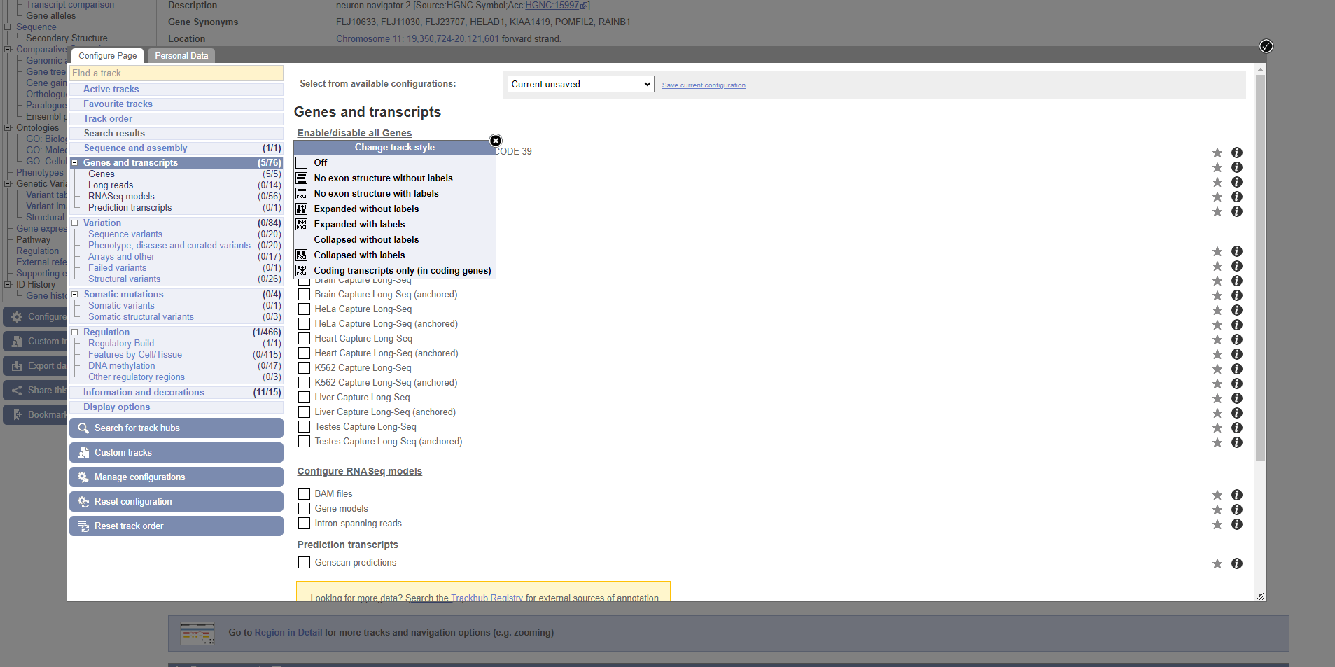**Fig9. Tracks configuration**

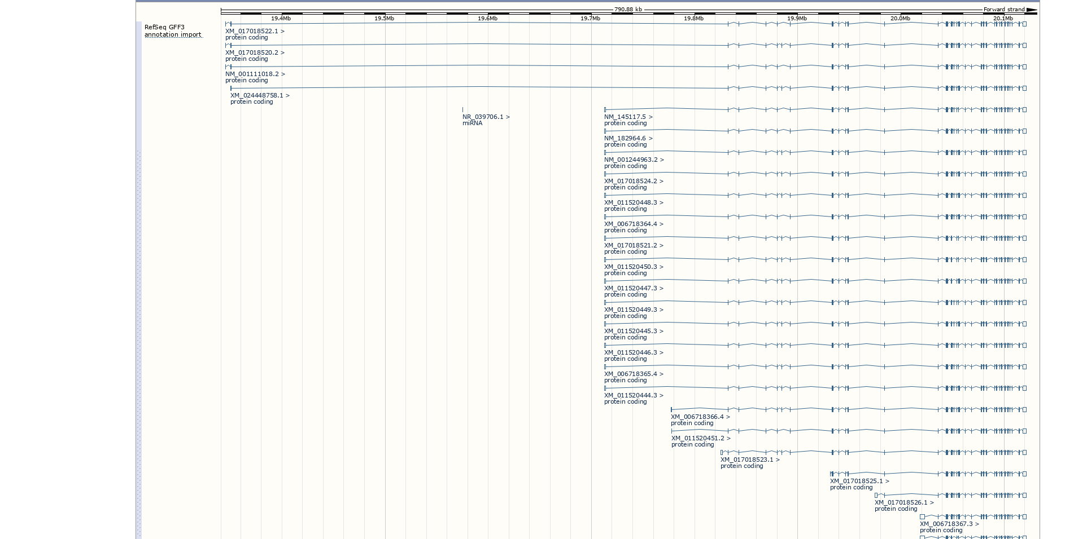**Fig10. Updated results after track configuration**

**RESULT:**

Emsembl genome browser was used to search for helad1 gene under human genome assembly and was explored for various tracks configuration options.

**CONCLUSTION:**

Ensembl genome browser provides annotation of (human) genomic sequence with genes and their constituent transcripts. Beyond providing access to data related to publicly available genome annotation, Ensembl integrates a number of tools designed to process or analyze your own data. Sequence alignment using BLAST and BLAT against Ensembl genes, genomes and proteins is also available, along with a suite of tools developed as part of the 1000 Genomes Project that can be accessed on the dedicated GRCh37 browser site.

**REFERENCES:**

1. Karolchik, D. (2003). The UCSC Genome Browser Database. , 31(1), 51–54. doi:10.1093/nar/gkg129
2. Ensembl genome browser 100. (n.d.-b). Uswest.ensembl.org. Retrieved March 28, 2022, from <https://asia.ensembl.org/index.html>
3. Homo_sapiens - Ensembl genome browser 104. (2014). Ensembl.org. Retrieved March 28, 2022, from <https://asia.ensembl.org/Homo_sapiens/Info/Index>
4. helad1 - Search - Homo_sapiens - Ensembl genome browser 105. (2021b). Ensembl.org. Retrieved March 28, 2022, from <https://asia.ensembl.org/Human/Search/Results?q=helad1>
5. Summary - Homo sapiens - Ensembl genome browser 100. (n.d.). Uswest.ensembl.org. Retrieved March 28, 2022, from <https://asia.ensembl.org/Homo_sapiens/Gene/Summary?db=core>
6. Summary - Homo sapiens - Ensembl genome browser 100. (n.d.). Uswest.ensembl.org. Retrieved March 28, 2022, from <https://asia.ensembl.org/Homo_sapiens/Gene/Summary?db=core;g=ENSG00000166833;r=11:19350724-20121601;t=ENST00000349880>
7. Summary - Homo sapiens - Ensembl genome browser 100. (n.d.). Uswest.ensembl.org. Retrieved March 28, 2022, from <https://asia.ensembl.org/Homo_sapiens/Transcript/Summary?db=core;g=ENSG00000166833;r=11:19350724-20121601;t=ENST00000349880>

**DATE: 30-03-22**

**WEBLEM 9c**

**Genome Data Viewer**

**(URL:** [**https://www.ncbi.nlm.nih.gov/genome/gdv/**](https://www.ncbi.nlm.nih.gov/genome/gdv/)**)**

**AIM:**

To explore graphical displays of features on NCBI's assembly of human genomic sequence data as well as cytogenetic, genetic, physical, and radiation hybrid maps using Genome Data Viewer (GDV).

**INTRODUCTION:**

**GDV** is composed of an **embedded instance of SV** that displays **sequence and track data**, along with **additional page elements** that allow a user to **search within an entire genome** assembly and efficiently **narrow in on their chromosome**, **sequence**, **region**, or **gene of interest**. GDV replaced the NCBI Map Viewer, **NCBI's previous** tool for whole-genome display. Researchers using GDV **can go directly** to the **NCBI BLAST** service from the browser and **load BLAST results** as alignment tracks that can be viewed **side by side** with **gene annotation** and other data. **Variation Viewer**, a related browser **associated with NCBI's** variation resources, is **functionally similar to GDV** and also **incorporates an instance of SV** but is **configured with features specifically intended for analyzing human variation data**. GDV and Variation Viewer can both **display the same types of NCBI** variation track data.

**METHODOLOGY:**

1. Open homepage for GDV genome browser (URL: <https://www.ncbi.nlm.nih.gov/genome/gdv/>)
2. Select human genome assembly
3. Search for DNA repair in genome
4. Select BRCA1 gene
5. Observe the results
6. Use various configuration options
7. Interpret the results.

**OBSERVATION:**

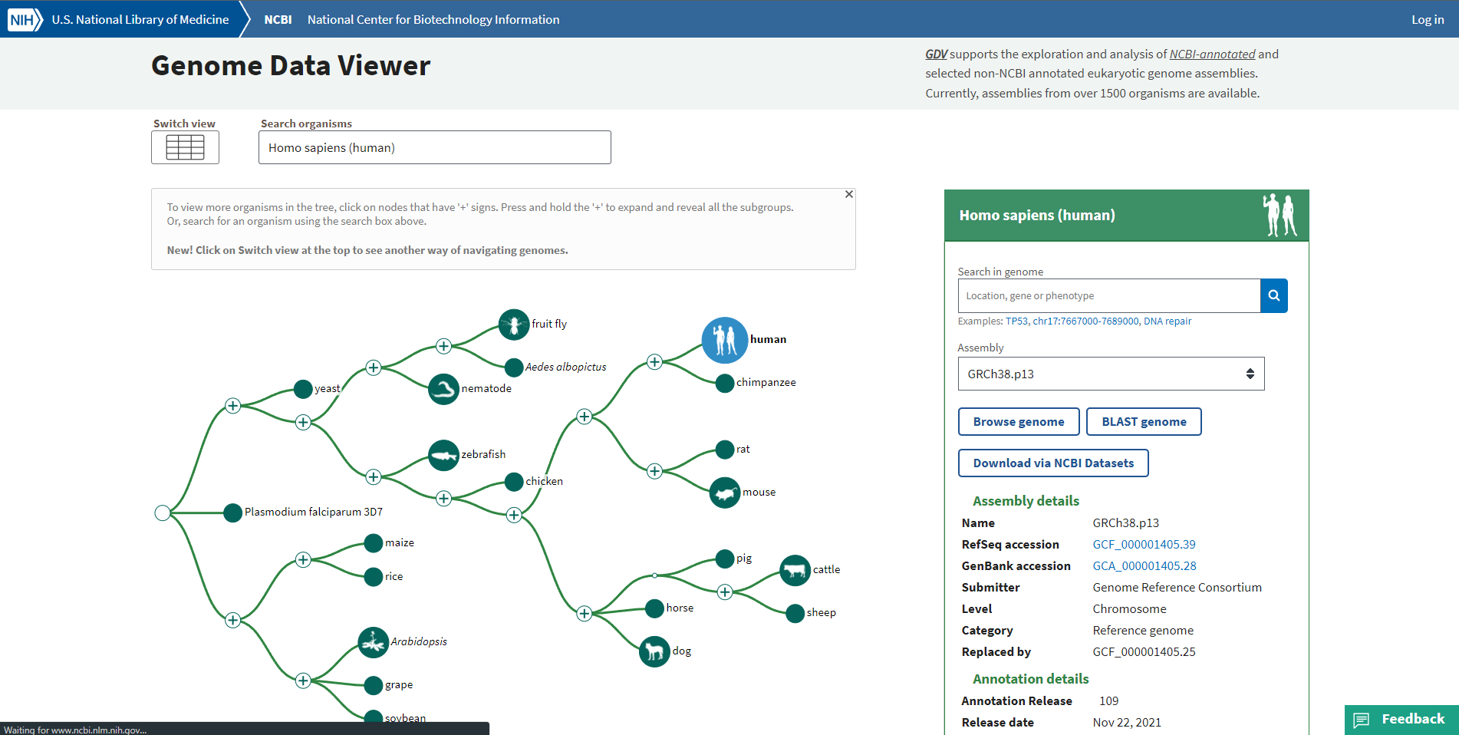**Fig1. Homepage for Genome Data Viewer**

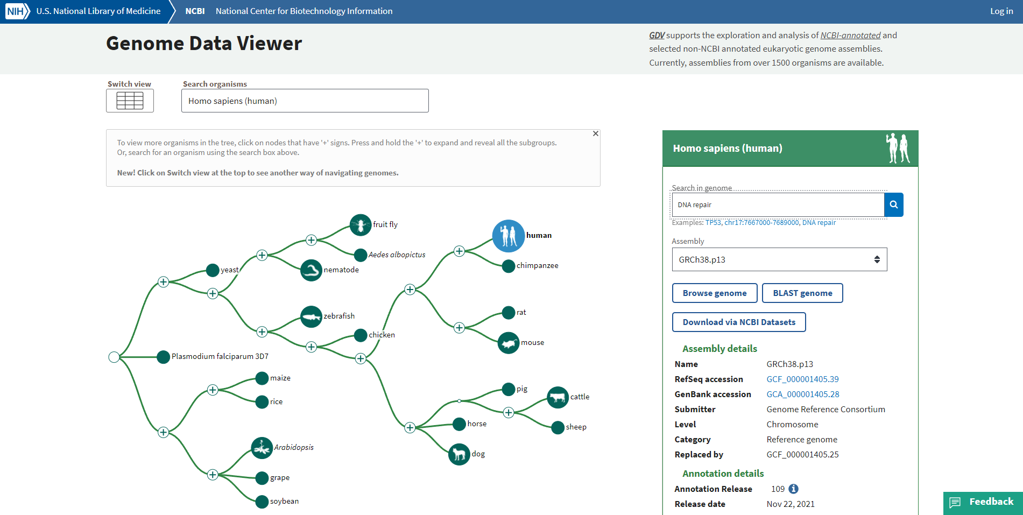**Fig2. Search for DNA repair in GRCh38.p13 assembly**

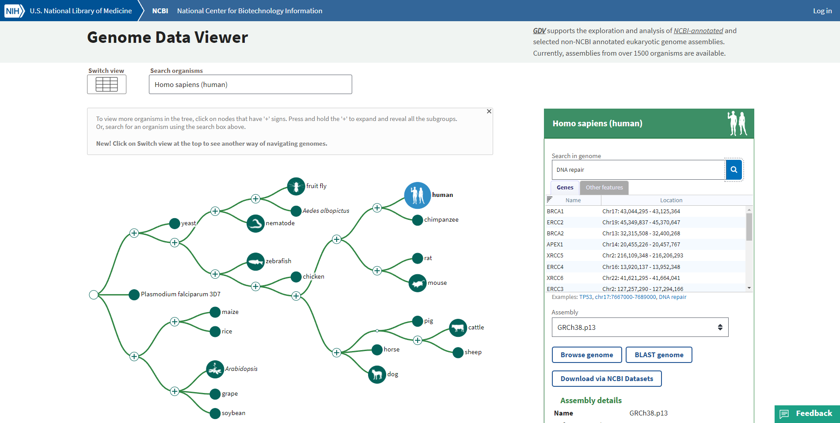**Fig3. Results for DNA repair genes**

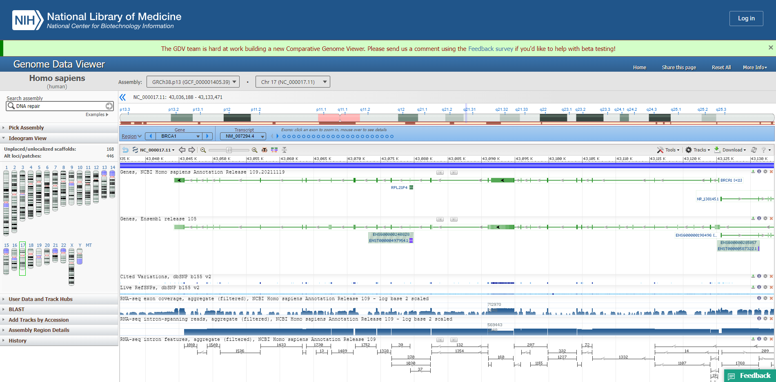**Fig4. Result for BRCA1 gene**

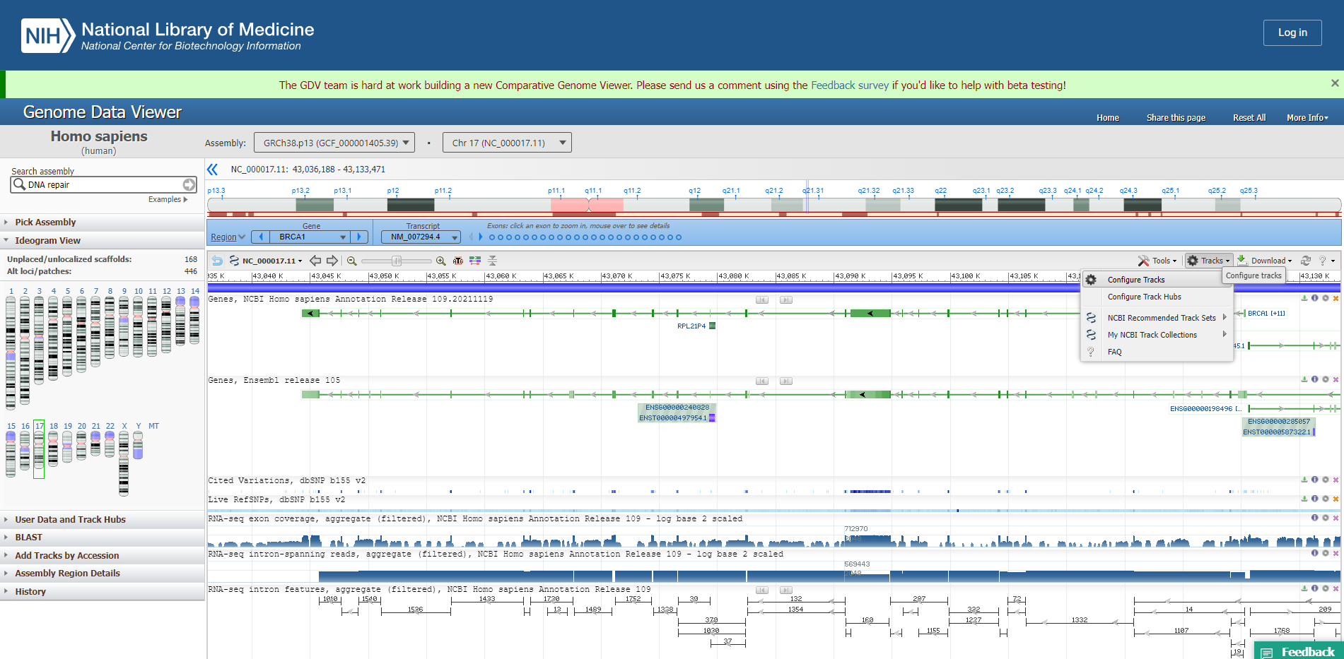**Fig5. Steps to configure tracks**

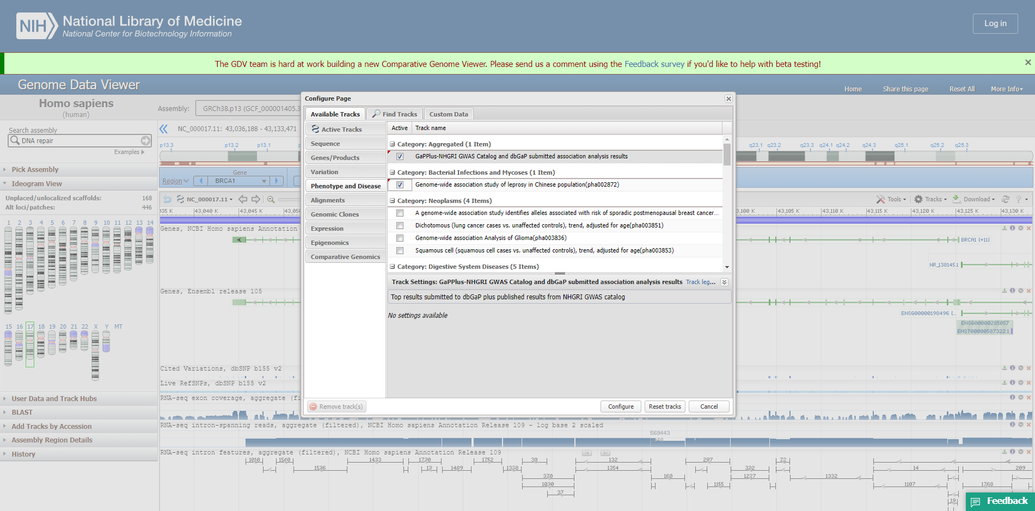**Fig6. Configuration page for phenotype and disease**

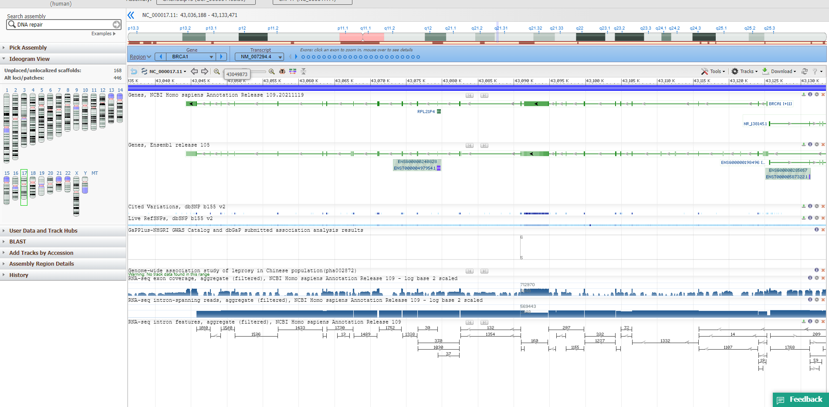**Fig7. Updated result after configuration**

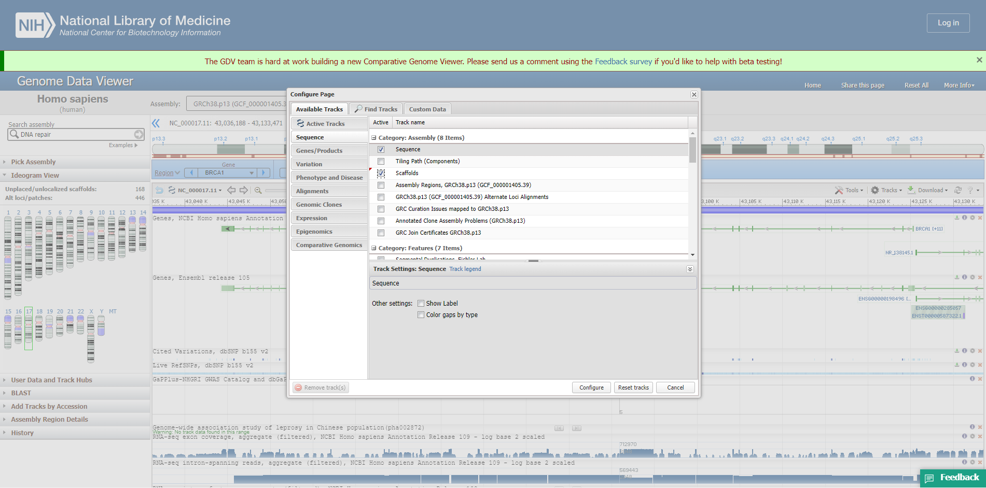**Fig8. Configuration page for sequence**

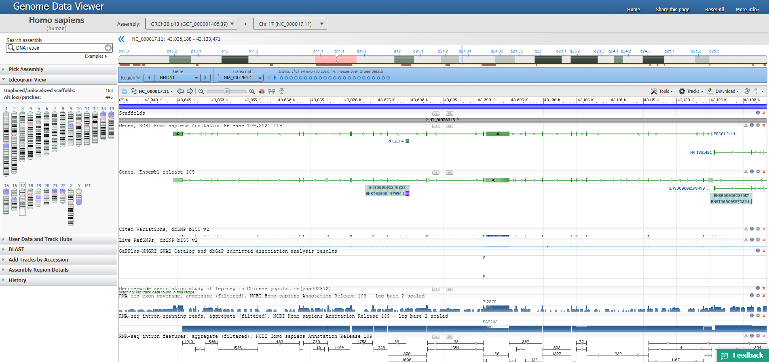**Fig9. Updated result after configuration**

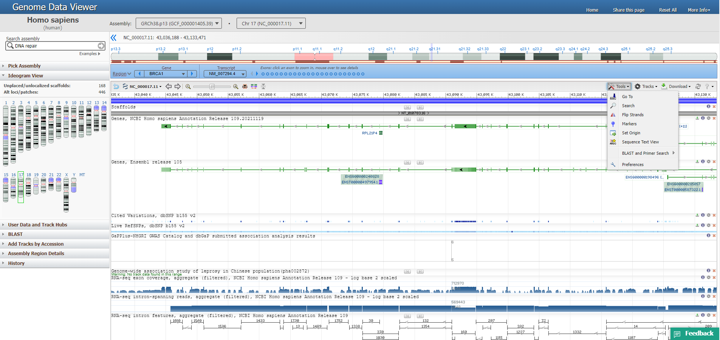**Fig10. Steps for sequence text view**

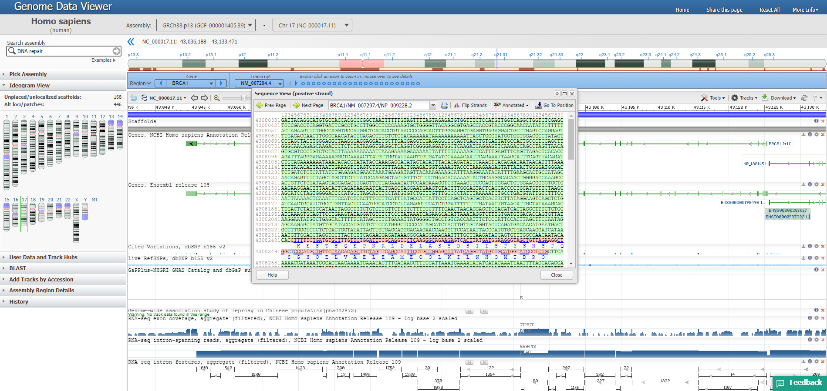**Fig11. Result for sequence text view**

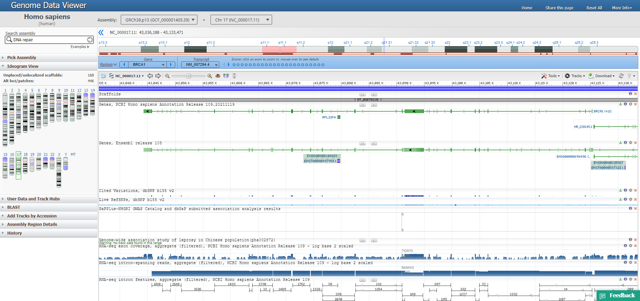**Fig12. Options to view exon information**

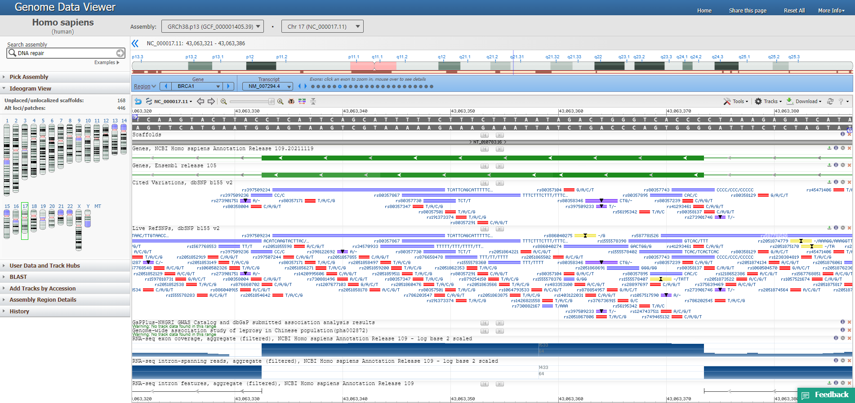**Fig13. Result for exon 18**

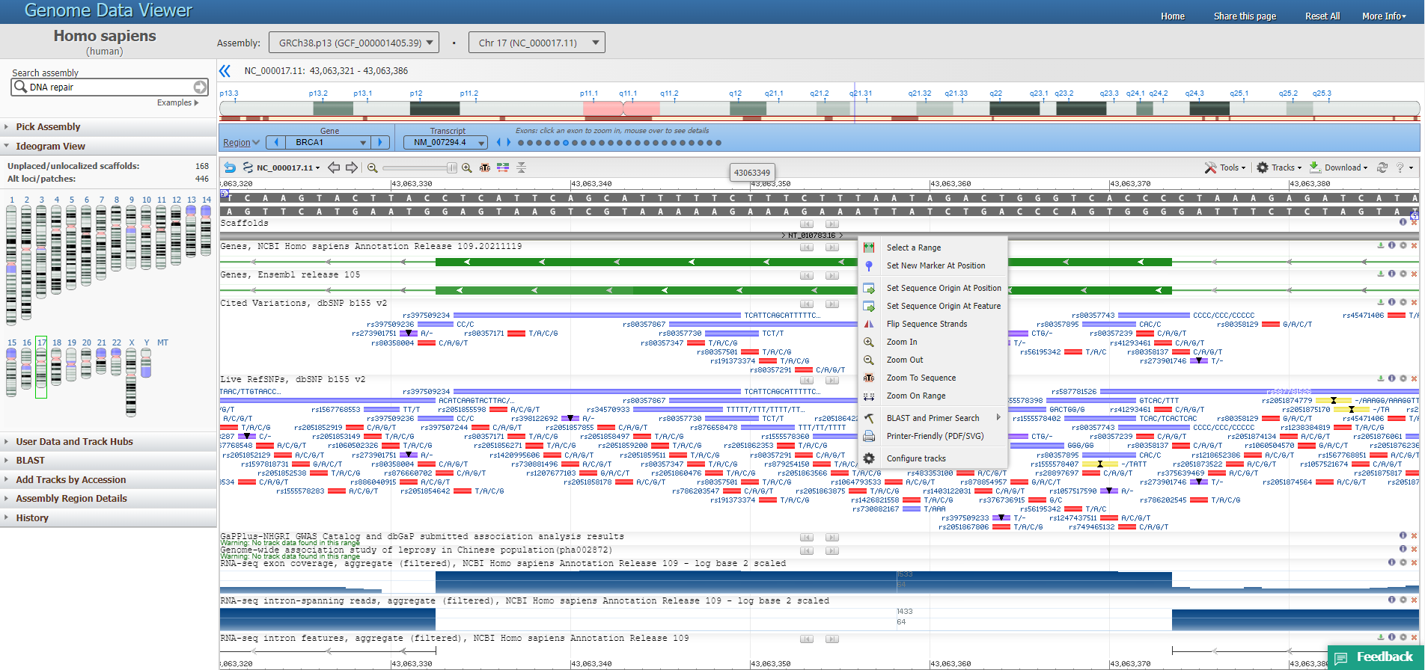**Fig14. Drag and select option for configuring tracks**

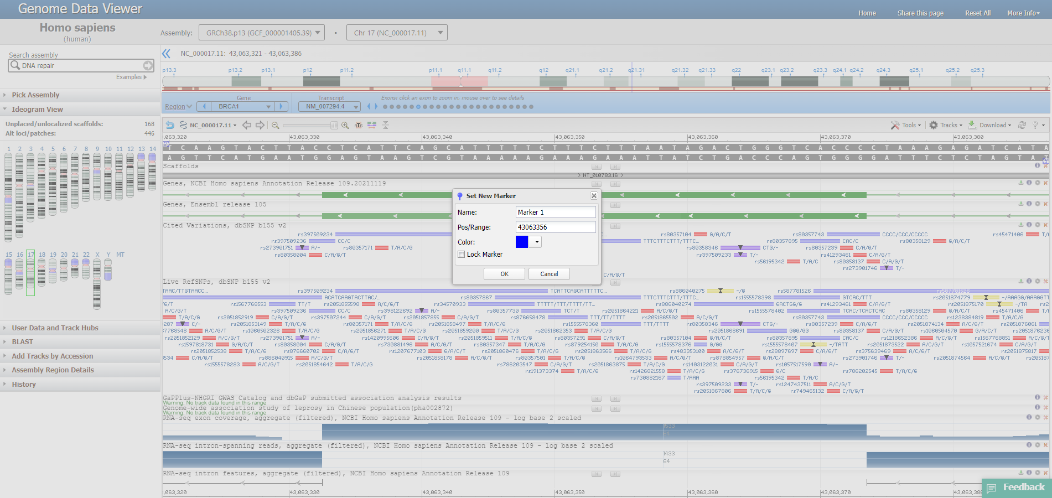**Fig15. Option to set new marker**

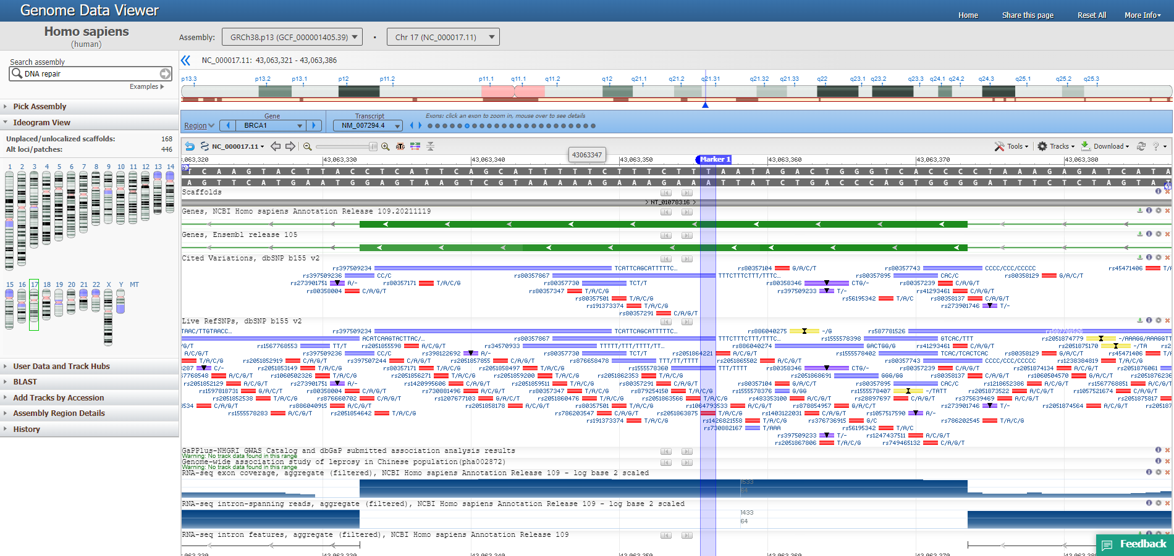**Fig16. Result for new marker**

**RESULT:**

GDV genome browser was used to search for DNA repair under human genome assembly and results were observed for BRCA1 gene. Various options for tracks configuration were explored and information regarding sequence and exons were also viewed.

**CONCLUSION:**

GDV can be used for visualization and analysis of the wide range of genomes and assemblies annotated at the NCBI. RefSeq gene annotation data tracks are shown by default in the graphical view for these assemblies. NCBI ref SNP data tracks are also shown by default for human assemblies. GDV offers users the ability to customize the displays of individual tracks. Users can hide or configure tracks from the track configuration panel or by using the icons at the right end of each track.

**REFERENCES:**

1. Rangwala, S. H., Kuznetsov, A., Ananiev, V., Asztalos, A., Borodin, E., Evgeniev, V., Joukov, V., Lotov, V., Pannu, R., Rudnev, D., Shkeda, A., Weitz, E. M., & Schneider, V. A. (2020). Accessing NCBI data using the NCBI Sequence Viewer and Genome Data Viewer (GDV). Genome Research, gr.266932.120. <https://doi.org/10.1101/gr.266932.120>
2. NCBI Genome Data Viewer. (n.d.). Www.ncbi.nlm.nih.gov. Retrieved March 28, 2022, from <https://www.ncbi.nlm.nih.gov/genome/gdv/>
3. Genome Data Viewer. (n.d.). Www.ncbi.nlm.nih.gov. Retrieved March 28, 2022, from <https://www.ncbi.nlm.nih.gov/genome/gdv/browser/genome/?id=GCF_000001405.39>